Business Requirements Document (BRD)

User Management Module
Field | Value
Document ID | BRD-K3-UM-001
Version | 4.16
Status | In review — pending Domain Expert sign-off
Module | User Management
Legal basis (primary) | Information Technology Act, 2000; Indian Registration Act, 1908 (appointment of Sub-Registrars); Aadhaar Act, 2016 (where biometric / Aadhaar is used)
State rules (primary) | Karnataka e-Governance hosting and security norms; MeitY / CERT-In / STQC / GIGW; Government Orders for office and post creation
Author (BA) | Nandha Kumar
Product Owner | Prashanth
Domain expert / reviewer | Prabhakar Naik
Target audience | Kaveri IT Cell, Department of Stamps and Registration, Government of Karnataka
Last updated | 2026-08-30

Document control

Version | Date | Author | Description
1.7 | 28-Aug-2026 | Nandha Kumar | Aligned to User Management BRD template; three user categories with OTP-only authentication (no password management); DSR division and role catalogue

1. Introduction

1.1 Purpose
This Business Requirements Document (BRD) defines the business requirements for the User Management Module of KAVERI 3.0 — the integrated platform of the Department of Stamps and Registration (DSR), Government of Karnataka. It describes a single unified Role Master and User Master differentiated by user category (Public/Citizen, DSR Officer, Other Department), OTP-based authentication (Username-based login — preferred Username for Citizens, KGID for departmental users; login OTP to mobile only; no password management), a separate Posts Master with Post–Role mapping (one post may map to multiple roles), Sanctioned Posts Master (Post + Office + strength), DSR Officer assignment to one or more sanctioned posts with available capacity (roles via Post–Role mapping; no Primary/Secondary assignment; multi-post login selection with office details), two distinct vacancy tests — available capacity for assignment and Transfer In, and a wholly unoccupied post for post-login additional charge (FR-UM-053) — single-role assignment for Other Department users with optional account end date, a Module Master (Registration of Documents, Marriage Registration, Encumbrance Search, Certified Copy, and others), Role-to-Module-Function privilege mapping, Module Function and Resource (API/URL) masters, runtime access enforcement, DSR officer organisational hierarchy maintenance, and dedicated user-creation workflows. It serves as the agreed basis for design, development, testing, and sign-off. It also defines Temporary Absence (Leave / OOD / Other) recorded by a hierarchy superior with temporary charge of the absent Post + Office to another subordinate under that superior (including cross-office peers such as SRO A → SRO B under a District Registrar), without freeing Transfer In capacity (6.6.6, FR-UM-079–FR-UM-084).

1.2 Background
KAVERI 3.0 requires a centralized mechanism to manage user identities, roles, sanctioned posts, and access permissions. There shall be one Role Master and one User Master for all categories — Public users (Citizens), Department users (DSR Officers), and Other Department users — differentiated by User Category (and Role Category on roles). Authentication shall be passwordless for all three categories: Username + Captcha + OTP sent only to the registered mobile; DSR Officers and Other Department users additionally verify Biometrics. Citizens choose their own preferred Username at registration, where both the email address and the mobile number are verified by separate OTPs before the account is created; KGID is the Username for DSR Officers and Other Department users, who record official email IDs. The Username is unique across the entire User Master and is the only unique login identifier — email and mobile number need not be unique. A Citizen who has lost the registered mobile may reset it before login by correctly answering three security questions selected at random from the five captured at registration and entering a PIN sent to the registered email; this reset path is not available to DSR Officers or Other Department users, whose mobile number is changed only by an authorised administrator. DSR officers are assigned to sanctioned posts from the Posts Master that still have capacity (strength per office in Sanctioned Posts Master). Posts are mapped to one or more roles in the Role Master via Post–Role mapping; a user may hold multiple sanctioned posts with no Primary/Secondary distinction and shall select one post (with office details) at login when multiple are active. Post assignment and Transfer In require available capacity at the office (Occupied < Sanctioned Strength), except that a future-dated Transfer In may reserve capacity when relieving is already recorded for that Post + Office (FR-UM-067). Additional charge under a subordinate post after login requires that post to be wholly unoccupied at the office (Occupied = 0). After login, an officer may take additional charge of such a subordinate post without logout or order (FR-UM-053). A scheduled job after midnight refreshes post assignments and Sanctioned Posts occupied counts from Transfer Out, Transfer In, and occupancy End Date (FR-UM-068). Other Department users are assigned exactly one role and may have an optional account end date that deactivates the user when reached. Application modules (e.g. Registration of Documents, Marriage Registration, Encumbrance Search, Certified Copy) are maintained in a Module Master and mapped to roles via Module Functions and Resources (APIs/URLs) — DSR organisational roles are not named after modules. The system shall maintain the DSR officer reporting hierarchy (organisational chart). Application Admin maintains these masters. Password management is explicitly out of scope A hierarchy superior may record Temporary Absence (Leave / OOD / Other) on an active occupancy without freeing the slot; while absent the officer cannot log in; the superior may assign Temporary Charge of that Post + Office to another officer under them, including at a different office in the same span (FR-UM-079–FR-UM-084).

1.3 Scope
In Scope:
- User registration for three categories in a single User Master: Public users (Citizens), Department users (DSR Officers), and Other Department users
- Username-based login for all categories (preferred Username for Citizens, KGID for departmental users); OTP to mobile only; Captcha; biometrics for departmental users; OTP and session policy (FR-UM-069–FR-UM-076); Citizen-only lost-mobile reset via three random security questions plus PIN to registered email; FR-UM-052 assigned-post login; FR-UM-053 post-login additional charge; FR-UM-054 display
- Single unified Role Master with Role Category differentiating Citizen, DSR, and Other Department roles (RBAC)
- Module Master, Module Function Master, Resource Master (API/URL), and Role–Module–Function mapping maintained by Application Admin
- DSR Officer Hierarchy Master (posts), Office Hierarchy Master, and Division Master (enumerated divisions)
- Post–Office-Type validation on sanctioned posts; Transfer Out / Relieving and Transfer In (office span then immediate-parent post only; future-dated Transfer In may reserve capacity when relieving is already recorded; Transfer/Reporting Order + Joining Date; login from 12:00 AM IST on Joining Date); midnight occupancy refresh job; office span via Office Hierarchy
- Temporary Absence (Leave / OOD / Other) recorded by hierarchy superior only; login blocked while any effective absence exists; Temporary Charge of the absent Post + Office to another subordinate under the superior (including cross-office peers, e.g. DRO assigns SRO A charge to SR of SRO B); capacity not freed for Transfer In; distinct from FR-UM-053 additional charge (FR-UM-079–FR-UM-084, 6.6.6, P-13)
- Dedicated step-by-step workflows for role assignment during user creation (DSR and Other Department)
- Administrative user management (create, edit, suspend, deactivate users)
- Audit logging of user-related activities

1.4 Out of Scope:
- Single Sign-On (SSO) integration with third-party identity providers (to be addressed in a future phase)

3. Business Objectives
The User Management Module aims to achieve the following business objectives:
- Provide a secure and reliable mechanism for users to register and access the system.
- Enable administrators to efficiently manage user accounts and access rights.
- Enforce role-based access control to protect sensitive data and functionality.
- Maintain the DSR Officer Hierarchy Master aligned to the Department organisational chart.
- Support Module Function and Resource (API/URL) masters with Role–Module–Function mapping and runtime access enforcement maintained by Application Admin.
- Reduce support overhead related to account access issues through reliable OTP delivery.
- Ensure compliance with organizational security and data privacy policies.
- Provide auditability of user actions for security and compliance reporting.

4. Stakeholders
Name / Role | Department | Responsibility
Kaveri IT Cell | Engineering | Reviews technical feasibility
Citizens (Public users) | External | Self-register and access citizen portal services
DSR Officers & Other Department users | Government | Access departmental modules via OTP + biometrics

5. Assumptions and Constraints

5.1 Assumptions
- Users will access the system via a web browser and/or mobile application.
- An email service is available for sending verification and notification emails.
- The organization has defined a standard set of user roles prior to implementation.

5.2 Constraints
- The module must comply with the Digital Personal Data Protection Act, 2023 (DPDP Act) and Karnataka state e-Governance and data-protection policies applicable to citizen and government-user data.
- The solution must integrate with the KAVERI 3.0 platform database, identity and authentication services, SMS and email gateways, and Aadhaar-compatible biometric authentication infrastructure deployed for the Department.
- Delivery must be completed within the approved project timeline and budget.

6. Functional Requirements
Approved Process Diagrams and Structure Figures — Index
ID | Name | Section | Editable source (.drawio)
P-01 | Citizen Self-Registration | 6.1.1 | ProcessDiagrams/User_Management/P-01_Citizen_Self_Registration.drawio
P-02 | Login (all categories) | 6.5.2.1 | ProcessDiagrams/User_Management/P-02_Login_All_Categories.drawio
P-03 | Citizen lost-mobile reset | 6.5.2.2 | ProcessDiagrams/User_Management/P-03_Citizen_Lost_Mobile_Reset.drawio
P-04 | Departmental mobile change | 6.5.2.3 | ProcessDiagrams/User_Management/P-04_Departmental_Mobile_Change.drawio
P-05 | DSR login post selection | 6.5.2.4 | ProcessDiagrams/User_Management/P-05_DSR_Login_Post_Selection.drawio
P-06 | Additional charge after login | 6.5.2.5 | ProcessDiagrams/User_Management/P-06_Additional_Charge_After_Login.drawio
S-01 | Access model | 6.5.1 | ProcessDiagrams/User_Management/S-01_Access_Model.drawio
S-02 | Two vacancy tests | 6.5.3 | ProcessDiagrams/User_Management/S-02_Two_Vacancy_Tests.drawio
S-03 | Runtime enforcement | 6.5.6 | ProcessDiagrams/User_Management/S-03_Runtime_Enforcement.drawio
S-04 | Officer Hierarchy tree | 6.5.7 | ProcessDiagrams/User_Management/S-04_Officer_Hierarchy_Tree.drawio
S-05 | Office Hierarchy tree | 6.5.8 | ProcessDiagrams/User_Management/S-05_Office_Hierarchy_Tree.drawio
S-06 | Span vs action | 6.5.8 | ProcessDiagrams/User_Management/S-06_Span_vs_Action.drawio
P-07 | DSR Officer user creation | 6.6.1 | ProcessDiagrams/User_Management/P-07_DSR_Officer_User_Creation.drawio
P-08 | Other Department user creation | 6.6.2 | ProcessDiagrams/User_Management/P-08_Other_Department_User_Creation.drawio
P-09 | Transfer Out / Relieving | 6.6.3 | ProcessDiagrams/User_Management/P-09_Transfer_Out_Relieving.drawio
P-10 | Transfer In | 6.6.4 | ProcessDiagrams/User_Management/P-10_Transfer_In.drawio
P-11 | Occupancy refresh job | 6.6.5 | ProcessDiagrams/User_Management/P-11_Occupancy_Refresh_Job.drawio
P-12 | Handover timeline | 6.6.4 | ProcessDiagrams/User_Management/P-12_Handover_Timeline.drawio
P-13 | Temporary Absence / Temporary Charge | 6.6.6 | ProcessDiagrams/User_Management/P-13_Temporary_Absence_Charge.drawio

6.1 User Registration
Registration and creation requirements for all three user categories are defined below (FR-UM-001–FR-UM-004, FR-UM-062–FR-UM-064). The Citizen self-registration workflow is detailed in 6.1.1; the corresponding administrator-driven workflows for DSR Officers and Other Department users are detailed in 6.6 (Administrative User Creation and Role Assignment Workflow).
Req ID | Requirement | Priority
FR-UM-001 | The system shall support instant self-registration for Public users (Citizens) with no approval workflow. Registration shall capture a preferred Username chosen by the registering user (FR-UM-062), email address, mobile number, and five security questions with answers (FR-UM-055). Both the email address and the mobile number shall be verified by separate OTPs before the account is created (FR-UM-063). | High
FR-UM-002 | The system shall allow Department users (DSR Officers) to be created only by authorised administrative roles. Creation shall capture KGID — which becomes the Username for this category (FR-UM-062, FR-UM-064) and is the governed unique login identifier — official email ID, and mobile number. Security questions are not captured for this category because no self-service mobile reset is offered (FR-UM-065). | High
FR-UM-003 | The system shall allow Other Department users (officers/staff from other government departments) to be created only by authorised administrative roles. Creation shall capture KGID — which shall be the Username for this category (FR-UM-062, FR-UM-064) — official email ID of the parent department, and mobile number. Security questions are not captured for this category because no self-service mobile reset is offered (FR-UM-065). | High
FR-UM-004 | The Username shall be the login identifier for all user categories. The Username shall be unique across the entire User Master (a single namespace covering Citizens, DSR Officers, and Other Department users) and the system shall reject creation of a duplicate Username. Email address and mobile number shall not be subject to a uniqueness constraint — the same email or mobile may legitimately appear on more than one account (for example family members sharing a mobile, or an office landline). See FR-UM-062. | High
FR-UM-062 | The system shall derive the Username by user category: for Public users (Citizens) the Username is a preferred Username entered by the registering user, and the system shall check availability against the whole User Master and reject a Username already in use; for DSR Officers and Other Department users the KGID shall be treated as the Username and shall not be user-selectable. The Username shall not be changeable by the user after creation. A correction to a Username (including a KGID correction) shall be performed only by an authorised administrator, with reason and audit trail. | High
FR-UM-063 | During Citizen self-registration the system shall verify both contact channels before creating the account: an OTP shall be sent to the entered email address and a separate OTP shall be sent to the entered mobile number, and both shall be entered correctly. If either verification is not completed, the account shall not be created. Each verification OTP shall be time-limited and single-use, and failed attempts shall be rate-limited and audit-logged. | High
FR-UM-064 | For DSR Officers and Other Department users the system shall validate that the KGID is present and unique in the User Master, and shall require an official email ID (government / parent-department email address) rather than a personal email address. Where a permitted official email domain list is configured, the system shall validate the entered email against that list and reject non-official domains. | High

6.1.1 Citizen Self-Registration Workflow (FR-UM-001, FR-UM-055, FR-UM-062, FR-UM-063)
Citizens self-register instantly with no approval workflow. The registering user chooses their own Username, which the system checks for availability across the entire User Master. Both the email address and the mobile number are verified by separate OTPs before the account is created, so neither channel can be claimed without proof of control. Five security questions are captured at this point; they are used only for the lost-mobile reset in FR-UM-056 and are entered by the citizen alone — never by an administrator.
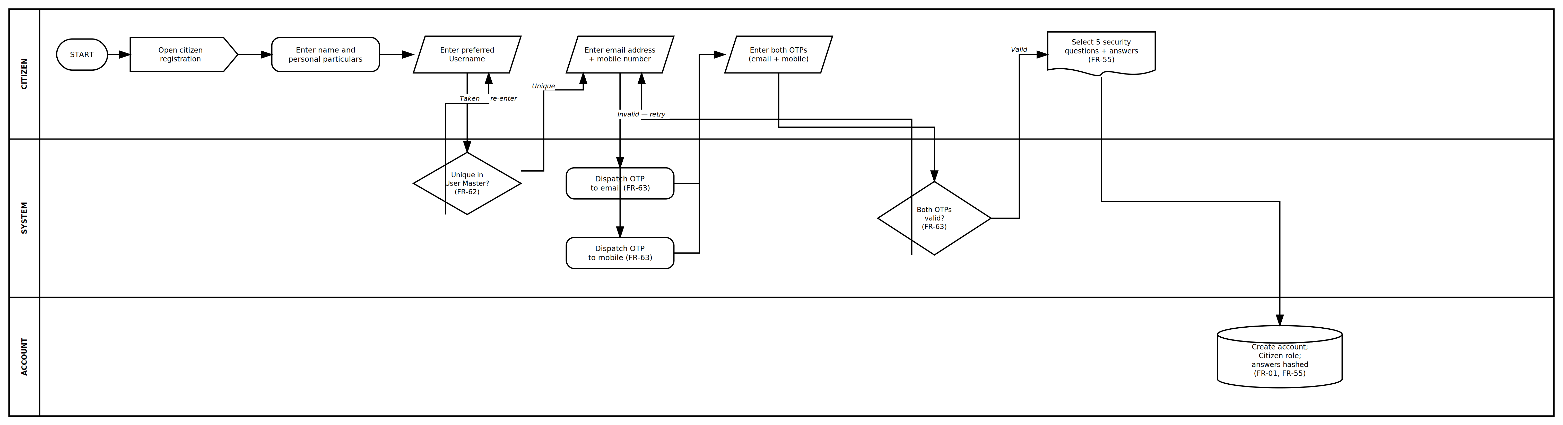
Approved process diagram — P-01 Citizen Self-Registration — FR-UM-001, FR-UM-055, FR-UM-062, FR-UM-063 — ProcessDiagrams/User_Management/P-01_Citizen_Self_Registration.drawio
Step | Action | Actor / System | Notes
1 | Open citizen registration; enter name | Citizen | Instant self-registration (FR-UM-001)
2 | Enter preferred Username; system checks availability | Citizen / System | Rejected if already in use anywhere in User Master (FR-UM-062)
3 | Enter email address and mobile number | Citizen | No uniqueness constraint on either (FR-UM-004)
4 | System dispatches an OTP to the entered email address | System | FR-UM-063; time-limited, single-use
5 | System dispatches a separate OTP to the entered mobile number | System | FR-UM-063; time-limited, single-use
6 | Enter both OTPs — email and mobile | Citizen | Account not created unless both verify (FR-UM-063)
7 | Select five distinct security questions and answer each | Citizen | All five mandatory; self-entered only (FR-UM-055)
8 | Save — account created; Citizen role assigned; answers stored hashed | System | FR-UM-001, FR-UM-055; no approval workflow

6.2 Authentication
Req ID | Requirement | Priority
FR-UM-005 | Public users (Citizens) shall authenticate using Username + Captcha + OTP on every login. OTP shall be sent only to the registered mobile number. | High
FR-UM-006 | Department users (DSR Officers) shall authenticate using Username (KGID) + Captcha + OTP + Biometrics on every login. OTP shall be sent only to the registered mobile number. | High
FR-UM-007 | Other Department users shall authenticate using Username (KGID) + Captcha + OTP + Biometrics on every login. OTP shall be sent only to the registered mobile number. | High
FR-UM-008 | The system shall allow users to log out and terminate their active session. | High
FR-UM-009 | The system shall not provide password-based login, password reset, or password change for any user category. | High
FR-UM-069 | The system shall enforce OTP and PIN validity as follows (IST clock): login OTP is valid for five (5) minutes from dispatch; Citizen registration email OTP, registration mobile OTP (FR-UM-063), and lost-mobile reset PIN (FR-UM-056) are each valid for ten (10) minutes from dispatch. On expiry the code is invalid and the user must request a new one. | High
FR-UM-070 | Login OTPs, registration OTPs, and the FR-UM-056 reset PIN shall be six (6) numeric digits. | High
FR-UM-071 | The system shall allow a maximum of three (3) incorrect entries per issued OTP or reset PIN. After the third failure that code is invalidated and the user must request a new one. | High
FR-UM-072 | The system shall enforce a thirty (30) second cooldown between successive OTP or PIN resend requests to the same user and channel (mobile or email), and a maximum of three (3) resends per channel per fifteen (15) minutes. | High
FR-UM-073 | After five (5) failed login or OTP verification attempts for a Username (separate from FR-UM-056 lost-mobile reset lockout), the system shall lock that Username for fifteen (15) minutes. Unlock is automatic when the lockout expires, or earlier by an authorised administrator with reason and audit trail. FR-UM-056 reset-flow lockout: five (5) failed question or PIN attempts lock that flow for thirty (30) minutes. | High
FR-UM-074 | The system shall terminate a session after fifteen (15) minutes of no user activity (idle timeout). Re-authentication is then required (OTP, and biometrics for departmental users). This applies especially to shared SRO counter machines where FR-UM-052/FR-UM-053 fix the session post for the whole session. | High
FR-UM-075 | The system shall terminate a session after an absolute maximum of eight (8) hours from login, even if the user is still active. Re-authentication is required to continue. | High
FR-UM-076 | The system shall allow only one active session per Username. A new successful login terminates any prior session for that Username (last-login-wins) and shall notify the prior session on next request that it has ended. | High
FR-UM-052 | After successful authentication, if a DSR Officer has more than one active sanctioned-post occupancy, the system shall present a mandatory post-selection step before entering the application. Each option shall be labelled consistently as "Role — Post Name — Office Name (Office Code)" (see FR-UM-053, FR-UM-054). The user shall select exactly one assigned post for the session. If the officer has only one active occupancy, the system shall auto-select that post and skip the selection screen. Login shall complete under that assigned post only — additional charge of a subordinate post (FR-UM-053) shall not be offered during the login flow. Initial Module Function claims on entering the home page shall derive from the selected assigned post via Post–Role mapping only — not from other post occupancies the officer may hold concurrently. When a post maps to multiple roles, claims are the union of Module Functions for those roles of that single selected post (not a union across multiple assigned posts). Other Department and Citizen users are not subject to post selection. | High
FR-UM-053 | After login — while the DSR Officer remains in the same session and without requiring logout — the system shall allow the officer to take additional charge of a wholly unoccupied subordinate post under the officer's assigned post (the post selected or auto-selected at login under FR-UM-052) at the same Office, using the DSR Officer Hierarchy Master (FR-UM-043). This is temporary in-office additional charge for the session; no Transfer Order, Reporting Order, or other order document is required (distinct from Transfer In under FR-UM-060). Eligibility: for the assigned Post at the same Office, examine each immediate child post in the hierarchy; that child post shall be offered only if it is wholly unoccupied at that Office — the occupied count is zero (FR-UM-066(b)). A post that has any occupant shall not be offered, even where sanctioned strength has not been fully used. Where a child post is unoccupied, the system shall continue one level further under it (cascade while posts remain unoccupied); a post with any occupant shall block cascading beneath it. Example: an SR logged in at SRO Yeshwanthapura; if no FDA is posted there, additional charge as FDA is allowed; if no SDA is posted under that unoccupied FDA, additional charge as FDA or SDA is allowed; if even one FDA is posted, FDA is not offered and SDA beneath it is not reachable. The officer may hold at most one additional charge subordinate post at a time. While additional charge is active, effective Module Function claims shall be derived from the additional charge post via Post–Role mapping only — assigned-post privileges shall not apply (e.g. a Sub-Registrar acting as FDA under additional charge shall not retain Sub-Registrar signing or approval functions until switching back). The officer may switch back to assigned-post context at any time during the session without logout; on switch-back, claims revert to the assigned post. When no additional charge is active, claims derive from the assigned post only. Selection, switch-back, and reversion shall be audit-logged (actor, assigned post, additional charge post or cleared, office, timestamp). The additional-charge picker shall label each option as "Role — Post Name — Office Name (Office Code)" — the same format as FR-UM-052 post selection and FR-UM-054 header display. | High
FR-UM-054 | After login, the home page and/or application header shall display the assigned Post (from FR-UM-052) with its mapped Role(s) and Office details using the format "Role — Post Name — Office Name (Office Code)" for the assigned post. When additional charge is active under FR-UM-053, the header shall show which context is currently driving session privileges — either assigned post only, or additional charge post (with assigned post still shown for reference but not active for access). Example with additional charge active: "Assigned: Sub-Registrar (SR) — Sub-Registrar — SRO Yeshwanthapura (OFF-SRO-YESH) | Active context: Additional charge — FDA (Enforcement) — FDA (Enforcement) — SRO Yeshwanthapura (OFF-SRO-YESH)". The officer may switch between assigned-post context and additional charge, or clear additional charge, from this header or an equivalent in-application control without logging out. | High
FR-UM-055 | During Citizen self-registration the system shall require the registering user to select five distinct security questions from a predefined list and to provide an answer to each. All five questions and answers are mandatory. Answers shall be stored hashed/encrypted, shall never be displayed or retrievable in clear text, and shall be used only for the Citizen lost-mobile reset flow (FR-UM-056). Security questions shall not be captured for DSR Officers or Other Department users, and shall never be entered on a user's behalf by an administrator. | High
FR-UM-056 | A Public user (Citizen) who has lost access to the registered mobile number shall be able to reset that mobile number before login as follows: the user enters the Username and Captcha; the system selects three of the five security questions registered under FR-UM-055 at random and presents them; all three answers must be correct; the system then sends a time-limited, single-use PIN to the registered email address; on correct entry of that PIN the user may enter a new mobile number, which shall itself be verified by an OTP sent to that new number before the change takes effect. Only after the new mobile is verified shall the account's registered mobile be updated and login continue with an OTP to the new mobile. Failed answers and failed PIN entries shall be rate-limited and shall lock the reset flow after a configured number of attempts. The completed change shall be notified to the registered email address and audit-logged. This flow is available only to Public users (Citizens) — see FR-UM-065 for departmental users. | High
FR-UM-065 | The lost-mobile reset flow (FR-UM-056) shall not be offered to DSR Officers or Other Department users. For these two categories the registered mobile number shall be changed only by an authorised administrator through the User Management admin console, with a reason recorded and a full audit trail. No pre-login self-service path to change the mobile number, email address, or Username shall exist for these categories. | High
See approved process diagram P-02 (Login — all categories) in 6.5.2.1.

6.3 OTP Login and Account Recovery
Req ID | Requirement | Priority
FR-UM-010 | The system shall dispatch the login OTP only to the user's registered mobile number (SMS) within 5 seconds of request. The login OTP shall never be sent to email. Email shall be used for exactly two one-time verification purposes: the email verification OTP during Citizen registration (FR-UM-063), and the reset PIN in the Citizen lost-mobile flow (FR-UM-056). | High
FR-UM-011 | The system shall validate Captcha before OTP dispatch for all user categories. | High
FR-UM-012 | Lost-mobile recovery is available only to Public users (Citizens) and shall follow FR-UM-056 (three random security questions of five, plus a PIN to the registered email, plus OTP verification of the new mobile). DSR Officers and Other Department users have no self-service recovery path; their mobile number is changed by an authorised administrator only (FR-UM-065). The system shall not provide password reset. The login OTP remains mobile-only in all cases. | High
See approved process diagram P-03 (Citizen lost-mobile reset) in 6.5.2.2.

6.4 User Profile Management
Req ID | Requirement | Priority
FR-UM-013 | The system shall allow users to view and update their profile information after login. The Username shall be displayed read-only and shall not be user-editable (FR-UM-062). Public users (Citizens) may update their mobile number after login, verified by an OTP to the new number, and may update their email address, verified by an OTP to the new address; they may also revise their five security questions and answers, which shall require an OTP to the registered mobile. For DSR Officers and Other Department users, mobile number and official email ID are maintained by an authorised administrator only (FR-UM-065). All such changes shall be audit-logged and notified to the user. | High
FR-UM-014 | The system shall allow users to upload and update a profile photo where applicable. | Medium
FR-UM-015 | RETIRED (v4.5) — Previously required administrators to deactivate user accounts with reason and audit trail. Superseded by FR-UM-020, which shall require a deactivation reason and audit trail. Number retained for traceability; do not implement separately. | —
See approved process diagram P-04 (Departmental mobile change) in 6.5.2.3.

6.5 Role-Based Access Control (RBAC)
Req ID | Requirement | Priority
FR-UM-016 | The system shall support RBAC using a single unified Role Master. Roles shall be differentiated by Role Category (Citizen, DSR, Other Department) as defined in Section 6.5.1. Users shall be stored in a single User Master differentiated by User Category. | High
FR-UM-017 | The system shall allow administrators to assign DSR Officers to one or more sanctioned posts with available capacity during user creation (at least one post required; FR-UM-066(a)). There is no Primary/Secondary role or post distinction. At login, the officer selects one active post for the session when multiple posts are assigned (FR-UM-052); session roles shall be those mapped to the selected assigned post via Post–Role mapping. Additional charge under FR-UM-053 is only after login. | High
FR-UM-028 | There shall be no separate Role Masters or User Masters for Citizens, DSR Officers, or Other Department users. All roles and users shall reside in one Role Master and one User Master respectively, differentiated by Role Category / User Category. | High
FR-UM-029 | During Other Department user creation, the system shall allow administrators to assign exactly one role from the Role Master filtered by Role Category = Other Department. Posts Master and sanctioned post occupancy do not apply to Other Department users. | High
FR-UM-030 | At least one sanctioned post with available capacity must be assigned to each DSR Officer at account creation (FR-UM-066(a)). Optional End Date may be set on a post occupancy only for genuinely time-bound deputations — not as a substitute for Transfer Out / relieving under FR-UM-057. When End Date is set, the system shall require a Deputation Reason code. The occupancy shall remain active until the end of the End Date and shall be freed after 11:59 PM IST of that date by the occupancy refresh job (FR-UM-068) — the same day boundary as FR-UM-058 relieving. Formal Transfer out / relieving shall follow FR-UM-057 and FR-UM-058. Transfer In shall follow FR-UM-060, FR-UM-061, and FR-UM-067. Occupancy de-allocation, reserved Transfer In becoming active, and Sanctioned Posts occupied-count updates shall be applied by the occupancy refresh job (FR-UM-068). | High
FR-UM-031 | RETIRED (v3.0) — Previously required mandatory end date on Secondary / additional post assignment for DSR Officers. Superseded by removal of Primary/Secondary assignment; optional End Date on any post occupancy is covered by FR-UM-030. Number retained for audit traceability; do not implement. | —
FR-UM-045 | A DSR Officer may be assigned to multiple sanctioned posts concurrently, provided each selected post has available capacity at assignment (Occupied < Sanctioned Strength — FR-UM-066). Over-capacity assignment shall be blocked. Occupied count shall increase per assigned post (including a reserved Transfer In under FR-UM-067) and decrease when occupancy ends (including after relieving under FR-UM-058). Transfer In assignments shall also require available capacity except where FR-UM-067 reservation against a recorded relieving applies. Occupied counts on the Sanctioned Posts Master shall be recalculated by the occupancy refresh job (FR-UM-068). | High
FR-UM-066 | The system shall apply two distinct vacancy tests and shall not treat them as interchangeable. (a) Available capacity — used for post assignment during user creation, for Transfer In, and for the post pick lists in those workflows — is satisfied when the occupied count for a Post at an Office is less than the sanctioned strength for that Post at that Office (Occupied < Sanctioned Strength). Occupied for this test shall include active occupancies and reserved (pending-join) Transfer In occupancies (FR-UM-067). An occupancy with a recorded Relieving Date still counts as occupied until the occupancy refresh job de-allocates it (FR-UM-058, FR-UM-068), except that Transfer In may reserve the slot being freed as defined in FR-UM-067. (b) Unoccupied post — used only for the FR-UM-053 post-login additional charge selection — is satisfied only when the occupied count for that Post at that Office is zero (Occupied = 0), irrespective of sanctioned strength. Reserved Transfer In occupancies also prevent Occupied = 0. A Post at an Office with sanctioned strength 2 and one occupant therefore has available capacity for assignment but is not unoccupied, and shall not be offered under FR-UM-053. Both counts shall be shown on sanctioned post occupancy screens and reports. | High
FR-UM-057 | The system shall support a Transfer out / relieving process for DSR Officers. An officer may be relieved from one or more currently assigned post occupancies (Post + Office). When the superior opens Transfer Out / Relieving, the system shall display only the offices that fall under the actor's session Office as per the Office Hierarchy Master (FR-UM-059) — i.e. the actor's own office and descendant offices. Within that office scope, the system shall list and allow relieving only of post occupancies where the actor's session Post is the immediate parent of the target Post in the DSR Officer Hierarchy Master (FR-UM-043). Office span is a first filter only: seeing a descendant office in the tree does not grant relieving of posts that do not report immediately to the actor. Example: District Registrar at DRO Mysuru sees SRO offices under DRO Mysuru and may relieve Sub-Registrar at those SROs (POST-SR reports to POST-DRO); Sub-Registrar at SRO Yeshwanthapura sees only that SRO and may relieve FDA/DEO under Sub-Registrar there. IGR or DIGR at Head Office may see statewide DRO/SRO offices in the span but may relieve only posts that report immediately to their session Post (e.g. IGR relieves DIGR; DIGR (Enforcement) relieves DRO) — not Sub-Registrar at an SRO. While relieving, the system shall capture Relieving Date and Relieving Order (order number / reference; upload of order document where applicable). Relieving actions shall be audit-logged. Citizens and Other Department users are out of scope for this process. | High
FR-UM-058 | After a relieving is recorded (FR-UM-057), the system shall retain the user–post occupancy until the end of the Relieving Date. The occupancy refresh job (FR-UM-068) shall de-allocate / remove the mapping of the user to the relieved post after 11:59 PM IST of the Relieving Date (i.e. occupancy ends at the close of that calendar day; the job runs shortly after midnight). Occupied count for that Post + Office shall then decrease unless a reserved Transfer In for the same Post + Office becomes active on the same job run (FR-UM-067). Where the count reaches zero the post also becomes wholly unoccupied and therefore eligible under FR-UM-053 (FR-UM-066). If the user has no remaining active post occupancies after de-allocation, login shall be blocked or limited per policy until a new post is assigned. De-allocation shall be audit-logged. | High
FR-UM-059 | The system shall maintain an Office Hierarchy Master for DSR offices. Structure: MS Building is the Secretariat office (root); under it is IGR Office (Head Office); under the Head Office are District Registrar Offices (DRO); under each District Registrar Office are Sub-Registrar Offices (SRO). Each Office shall have Office Code, Office Name, Office Type (Secretariat / Head Office / District Registrar Office / Sub-Registrar Office), and optional Parent Office. Application Admin shall add, edit, enable/disable, and update offices with audit trail. Sanctioned Posts and Transfer Out / Transfer In office scoping shall use this hierarchy (FR-UM-024, FR-UM-057, FR-UM-060). POST-ACS-SEC is sanctioned at MS Building (Secretariat). | High
FR-UM-060 | The system shall support a Transfer In process for DSR Officers. A superior (within office span per FR-UM-059 and immediate-parent post parentage per FR-UM-043, same rules as Transfer Out — office span does not expand parentage) may assign an officer to a sanctioned post (Post + Office). The system shall allow Transfer In to a post that has available capacity at that office (Occupied < Sanctioned Strength — FR-UM-066(a)), or, when the post is at full strength, only as a reserved future-dated occupancy under FR-UM-067 where relieving is already recorded. While processing Transfer In, the system shall capture Transfer Order / Reporting Order (order number / reference; upload of order document where applicable) and Joining Date. A reserved occupancy shall count toward occupied (FR-UM-066(a)) from the moment it is recorded; login remains blocked until Joining Date (FR-UM-061). The occupancy becomes active and Sanctioned Posts occupied counts are refreshed by the midnight job (FR-UM-068). Transfer In actions shall be audit-logged. Citizens and Other Department users are out of scope for this process. | High
FR-UM-061 | For a Transfer In occupancy (FR-UM-060), including a reserved occupancy under FR-UM-067, the user shall be allowed to log in and use that post only from 12:00 AM IST (start) of the Joining Date onwards. Before 12:00 AM IST of the Joining Date, login for that post shall be blocked (or the occupancy shall not appear as selectable under FR-UM-052). The occupancy refresh job (FR-UM-068) shall activate the reserved occupancy as of Joining Date so that from 12:00 AM IST on the Joining Date the post occupancy is available for login and session selection. | High
FR-UM-067 | Where a Transfer In is required against a Post + Office that is currently at full sanctioned strength, the system shall allow a future-dated Transfer In only if a relieving (FR-UM-057) has already been recorded for an occupancy of that same Post + Office, and that relieving slot is not already reserved by another Transfer In. The Joining Date shall be on or after the calendar day following the Relieving Date of the occupancy being replaced (i.e. after 11:59 PM IST of Relieving Date — example: outgoing officer relieved 31-Aug, incoming Joining Date 01-Sep or later). Recording the Transfer In shall immediately reserve one unit of capacity: the reserved occupancy counts toward Occupied for FR-UM-066(a) so that a second incoming officer cannot be assigned to the same slot, but the incoming officer cannot log in until Joining Date (FR-UM-061). If no relieving is recorded for that Post + Office, Transfer In to a full post shall remain blocked. Transfer In to a post that already has available capacity does not require a prior relieving. | High
FR-UM-068 | The system shall run a scheduled occupancy refresh job shortly after midnight IST each calendar day (after 12:00 AM IST). On each run the job shall: (1) de-allocate user–post occupancies whose Relieving Date has ended (FR-UM-058) or whose optional occupancy End Date has been reached (FR-UM-030); (2) activate reserved Transfer In occupancies whose Joining Date is the current calendar day (FR-UM-060, FR-UM-061, FR-UM-067); (3) recalculate and persist occupied count, remaining capacity, and wholly-unoccupied flag on the Sanctioned Posts Master for every Post + Office affected (FR-UM-048, FR-UM-066); (4) refresh the officer's effective post assignments so that login post selection (FR-UM-052) reflects only occupancies that are active as of that day. The job shall be idempotent, audit-logged (run timestamp, occupancies ended, occupancies activated, before/after occupied counts), and shall raise an operational alert on failure so that relieving and joining dates are not left unenforced. | High
FR-UM-077 | The system shall maintain a Division Master — an enumerated list of DSR organisational divisions (Division Code, Division Name, Display Order, Is Active). Posts Master, Hierarchy Master nodes, and Role Master seed groupings shall reference Division Code from this master — free-text division labels shall not be used on new or edited records. Application Admin shall add, edit, enable/disable, and update divisions with audit trail. Seed divisions are listed in Section 6.5.1. | High
FR-UM-078 | The system shall maintain a Post–Office-Type Allowed mapping defining which Post codes (from Posts Master) may be sanctioned at which Office Types (from Office Hierarchy Master — Secretariat, Head Office, District Registrar Office, Sub-Registrar Office). When creating or updating a Sanctioned Posts row or assigning a post to an officer, the system shall reject combinations not permitted by this mapping (FR-UM-024, FR-UM-048). Seed mapping for all active Posts is listed in Section 6.5.3 (e.g. POST-ACS-SEC only at Secretariat / MS Building; POST-SR, POST-FDA-ENF, POST-SDA-ENF, POST-DEO only at Sub-Registrar Office; POST-DRO only at District Registrar Office; POST-IGR and Head Office division posts only at Head Office). Application Admin shall maintain the mapping with audit trail. | High
FR-UM-046 | The system shall maintain a separate Posts Master for DSR establishment posts (e.g. Sub-Registrar (SR), FDA (Enforcement), DEO, DRO, HQA (Enforcement)). Each Posts Master row shall reference a Division Code from the Division Master (FR-UM-077). Application Admin shall add, edit, enable/disable, and update posts. Posts Master is distinct from Role Master. | High
FR-UM-047 | The system shall maintain a Post–Role mapping table. Each Post shall map to the corresponding unique Role(s) from the Role Master. Division-specific posts (e.g. POST-DIGR-ADMIN, POST-DIGR-ENF) shall not be mapped to roles of other divisions, so that assigning one post does not grant Admin + Vigilance + Enforcement access together. Application Admin shall add, edit, and remove mappings with audit trail. One post may map to multiple roles only when those roles intentionally belong to the same post's functional scope (not across unrelated divisions). The system shall block sanctioning or assignment of any Post that has no active Post–Role mapping row — an officer assigned to an unmapped post would receive zero roles (FR-UM-017). Example rows in this BRD are the complete seed mapping for all active Posts; Application Admin may add further mappings with audit trail. Domain Expert (Prabhakar Naik) shall confirm the seed list before go-live. | High
FR-UM-048 | The Sanctioned Posts Master shall reference a Post from the Posts Master (not Role directly), an Office from the Office Hierarchy Master (by Office Code), and sanctioned strength. The Post + Office Type combination shall be validated against the Post–Office-Type Allowed mapping (FR-UM-078). Strength, occupied count, remaining capacity, and whether the post is wholly unoccupied are maintained per Post per Office (FR-UM-066). Occupied count shall include active occupancies and reserved Transfer In occupancies (FR-UM-067) and shall be recalculated by the occupancy refresh job (FR-UM-068). | High
FR-UM-049 | Posts Master entries for DSR leadership and staff shall be division-specific where the organisation chart distinguishes them (e.g. POST-DIGR-ADMIN, POST-DIGR-VIG, POST-DIGR-ENF, POST-FDA-ADMIN, POST-FDA-ENF). Generic posts that would map to all division variants of DIGR/AIGR/FDA/SDA are not permitted in seed data. | High
FR-UM-033 | During Other Department user creation, the system shall allow an optional End Date. If an End Date is entered, the system shall automatically deactivate the user account on that date and block login thereafter. | High
FR-UM-034 | When assigning a role to a user, the system shall present only roles whose Role Category matches the user's User Category (Citizen roles for Citizens, DSR roles for DSR Officers, Other Department roles for Other Department users). | High
FR-UM-035 | The Role Master shall include the seed roles listed in Section 6.5.4 for Role Category = Citizen, Role Category = Other Department, and Role Category = DSR (Department). Application Admin may add, edit, or deactivate roles within each Role Category. | High
FR-UM-036 | The system shall maintain a Module Master of application modules (including Registration of Documents, Marriage Registration, Encumbrance Search, Certified Copy, and others listed in Section 6.5.6). Modules are not DSR organisational roles; they define functional areas to which roles are mapped. Registration of Documents is a single module with no online/offline classification in this master. | High
FR-UM-037 | The system shall allow Application Admin to map roles to Module Functions (Role–Module–Function mapping). Access to a module capability is granted only through this mapping (except Application Admin system privileges — see FR-UM-051). Each mapping row shall reference an exact Role Master name (unique role name) and a valid Module Function code. Application Admin shall add, edit, and update mappings with audit trail. | High
FR-UM-039 | The system shall maintain a Module Function Master under each module (e.g. VIEW, ADD, EDIT, APPROVE, SIGN, PRINT, DOWNLOAD). Application Admin shall add, edit, and update module functions. | High
FR-UM-040 | The system shall maintain a Resource Master of APIs and URLs linked to Module Functions (resource type API or URL, HTTP method, path pattern, Is Public flag). Application Admin shall add, edit, and update resources. Roles shall not store raw API/URL lists; access is resolved via Role → Module Function → Resource. Is Public = Yes marks resources accessible without authentication (deny-by-default otherwise — FR-UM-041). | High
FR-UM-041 | At runtime the application shall enforce access as follows: resolve the user's session roles (for DSR Officers: assigned post from FR-UM-052 when no additional charge is active; additional charge post only when FR-UM-053 is active); load Role–Module–Function claims per FR-UM-038; for each API/URL request look up the Resource Master using Type + Method + Path pattern matching with the most specific matching pattern taking precedence when multiple patterns match (longer / more specific path wins over shorter prefix). If no resource matches, access shall be denied (HTTP 403) unless the resource is explicitly marked Is Public = Yes in the Resource Master — deny-by-default. Allow only if the user holds the required Module Function for a matched non-public resource; otherwise deny (HTTP 403) and audit the attempt. Application Admin system principals are authorised for FN-UM-ADMIN outside Role–Module–Function mapping (FR-UM-051). | High
FR-UM-050 | Role–Module–Function mapping entries shall be validated against exact Role Master names (referential integrity). The system shall reject save of a mapping whose Role name does not match an active Role Master entry character-for-character (e.g. bare FDA is invalid when only FDA (Admin), FDA (Enforcement), etc. exist). Post–Role mapping and Hierarchy Master entries shall reference Posts Master Post Name character-for-character (same discipline as Role names). Same integrity pattern as Hierarchy ↔ Posts (FR-UM-044). | High
FR-UM-051 | Application Admin is a system-level / deployment-seeded actor, not a Role Master seed role and not created via the normal User Master creation workflow. Privileges for maintaining masters (including FN-UM-ADMIN resources) are granted to this principal outside Role–Module–Function mapping. Application Admin shall not appear as a DSR (or other) row in the Role–Module–Function example catalogue. Dual authorisation / maker-checker is not required for user creation or master maintenance in this module. DSR and Other Department user creation does not capture security questions (FR-UM-055, FR-UM-065). | High
FR-UM-042 | Application Admin shall create, edit, enable/disable, and update Module Master, Module Function Master, Resource Master, and Role–Module–Function mapping tables from the User Management admin console. All changes shall be audit-logged. | High
FR-UM-038 | A user's effective module access for a session shall be determined as follows: for DSR Officers, when no additional charge is active under FR-UM-053, Module Functions mapped to the assigned post (FR-UM-052) apply; when additional charge is active, only Module Functions mapped to the additional charge subordinate post apply — assigned-post privileges are suspended until the officer switches back to assigned-post context without logout; for Other Department users, the single assigned role; for Citizens, assigned Citizen roles. | High
FR-UM-018 | The system shall restrict access to features, APIs, and URLs based on the user's assigned role(s) and Role–Module–Function / Resource mappings. | High
FR-UM-019 | The system shall maintain DSR organizational divisions in the Division Master (FR-UM-077) and DSR roles within the unified Role Master (Role Category = DSR) as defined in Section 6.5.1 and the DSR Officer Hierarchy Master in Section 6.5.7. | High
FR-UM-043 | The system shall maintain a DSR Officer Hierarchy Master representing the reporting structure of Department officers (organisational chart). Each hierarchy node shall reference a Post from the Posts Master (not a Role) and an optional parent hierarchy node (also a Post). Application Admin shall add, edit, reorder, enable/disable, and update hierarchy nodes with audit trail. Reporting lines are position-based so that a specific post holder has one parent post in the tree. | High
FR-UM-044 | The DSR Officer Hierarchy Master shall seed and support the structure: Additional Chief Secretary / Principal Secretary / Secretary → Inspector General of Registration & Commissioner of Stamps → Divisions (Admin Law & Computers; Vigilance; Computers; Enforcement; Intelligence & Audit; DIGR CVC) with subordinate posts as listed in Section 6.5.7. Every hierarchy node Post must exist in Posts Master; every mapped Role in Post–Role mapping must exist in Role Master with a unique role name. | High
FR-UM-024 | The system shall maintain a Sanctioned Posts Master that references Posts Master entries and records sanctioned strength (approved headcount) for each Post at each office. Sanctioned strength applies only to DSR Posts Master entries. Each row shall satisfy Post–Office-Type Allowed rules (FR-UM-078). | High
FR-UM-025 | The system shall allow Application Admin to configure and update sanctioned strength per Post per office in the Sanctioned Posts Master, with audit trail of changes. Invalid Post + Office Type combinations shall be blocked (FR-UM-078). | High
FR-UM-026 | DSR department users shall be assigned only to posts defined in the Posts Master and sanctioned in the Sanctioned Posts Master. A user may hold multiple post occupancies. Assignment to an unlisted post, or to a sanctioned post already at full strength (over-capacity), shall be blocked (FR-UM-066(a)). | High
FR-UM-027 | The system shall display sanctioned strength, occupied count, and remaining vacancies per Post per office, and prevent over-capacity assignment. When assigning posts to a DSR Officer, only sanctioned posts with available capacity shall be selectable (FR-UM-066(a)). Screens shall make clear whether a post is wholly unoccupied or only partly filled, since FR-UM-053 requires a wholly unoccupied post (FR-UM-066(b)). Occupied count shall include reserved Transfer In occupancies (FR-UM-067) and shall be kept current by the occupancy refresh job (FR-UM-068). | High
FR-UM-032 | The system shall provide dedicated step-by-step workflows for role assignment during user creation for DSR Officers (Section 6.6.1) and Other Department users (Section 6.6.2). | High
FR-UM-079 | The system shall allow a hierarchy superior to record a Temporary Absence against an active DSR Officer post occupancy (Post + Office). Absence types shall include Leave, OOD (Out of Duty / Office Duty), and Other, with a mandatory reason code, inclusive from_date and to_date (IST calendar days), and optional order reference / uploaded order document. Absence shall be recorded by the superior only — the absent officer shall have no self-service create or approve path. The absence is a linked record on the occupancy; it shall not end the occupancy and shall not substitute for Transfer Out / relieving (FR-UM-057) or deputation End Date (FR-UM-030). Scope to create/amend/cancel shall follow office span (FR-UM-059) and immediate-parent post parentage (FR-UM-043) — the same filters as Transfer Out. Citizens and Other Department users are out of scope. All create, amend, and cancel actions shall be audit-logged. | High
FR-UM-080 | While an Approved temporary absence covers the current IST calendar day for any of an officer's active post occupancies (effective absence), the system shall deny login for that Username (KGID). The officer shall not select another assigned post under FR-UM-052 for the same period. On cancel of the absence, or after 23:59 IST of to_date (FR-UM-084 / FR-UM-068), login shall be allowed again. The login denial message shall state that the officer is on Leave / OOD / Other until the to_date. | High
FR-UM-081 | Temporary absence shall not free sanctioned capacity. The absent occupancy shall continue to count toward Occupied for available-capacity tests (FR-UM-066(a)) and for Transfer In / reserved occupancy (FR-UM-067). Transfer In shall not treat the post as vacant solely because of absence. Wholly-unoccupied tests for FR-UM-053 additional charge (FR-UM-066(b)) remain Occupied = 0 and are unaffected — an occupied-but-absent post shall not be offered under FR-UM-053. | High
FR-UM-082 | While an occupancy is under temporary absence (or as part of the same superior workflow), the superior may assign Temporary Charge of that absent Post + Office to another DSR Officer who holds an active occupancy under the same superior (office span FR-UM-059 and posts under the superior in Officer Hierarchy FR-UM-043). Cross-office assignment within the superior's span is allowed — for example a District Registrar may assign temporary charge of Sub-Registrar at SRO A to the Sub-Registrar of SRO B under the same district; an AIGR (Admin) may assign temporary charge of one District Registrar to another District Registrar under them. The covering officer shall not be the absentee and shall not themselves be under effective absence (FR-UM-080). At most one active temporary charge shall exist per absent Post + Office at a time; the superior may cancel and reassign. Temporary charge is dated and linked to the absence; it is not a Transfer In (FR-UM-060), not relieving (FR-UM-057), and not FR-UM-053 session additional charge. Assignment and cancellation shall be audit-logged (optional order reference). | High
FR-UM-083 | An officer holding an active temporary charge shall authenticate like any DSR Officer. At FR-UM-052 post selection the system shall list their active assigned posts and each active temporary-charge Post + Office, labelled for example "Temporary charge — Role — Post Name — Office Name (Office Code) — covering <Absent Officer Name>". Selecting a temporary-charge row sets session Module Function claims from that covered post via Post–Role mapping only (one active context; same spirit as FR-UM-038). The officer may switch back to an assigned-post context without logout where the product provides an in-session control (same pattern as FR-UM-053 switch-back). FR-UM-054 / header display shall show which context is active and the office of the covered post. Temporary charge is distinct from FR-UM-053: it is superior-assigned, may be cross-office, and applies while the primary occupancy remains occupied. | High
FR-UM-084 | Temporary absence is effective through 23:59 IST of to_date. The occupancy refresh job (FR-UM-068) — or equivalent day-boundary evaluation — shall clear effective absence and end linked temporary charge mappings after that boundary, and shall remove temporary-charge rows from FR-UM-052 for subsequent logins. Superior cancel of absence or of temporary charge shall take effect immediately for login and post selection. The system shall provide an absence and temporary-charge report (officer, Post + Office, type, reason, dates, cover officer, actor, timestamps) and shall retain audit history for at least seven years consistent with other UM audit events. | High

6.5.1 Unified Role Master and User Master
The system shall maintain a single Role Master and a single User Master for all user types. There shall be no separate masters for Citizens, DSR Officers, or Other Department users. Differentiation is by Role Category on roles and User Category on users. When assigning a role, the system shall filter the Role Master to roles matching the user's User Category (FR-UM-034).

Master | Differentiator | Values | Purpose
User Master | User Category | Public (Citizen); DSR Officer; Other Department | One user store; category drives auth, creation path, and eligible roles
Role Master | Role Category | Citizen; DSR; Other Department | One role store; category filters which roles can be assigned to which users
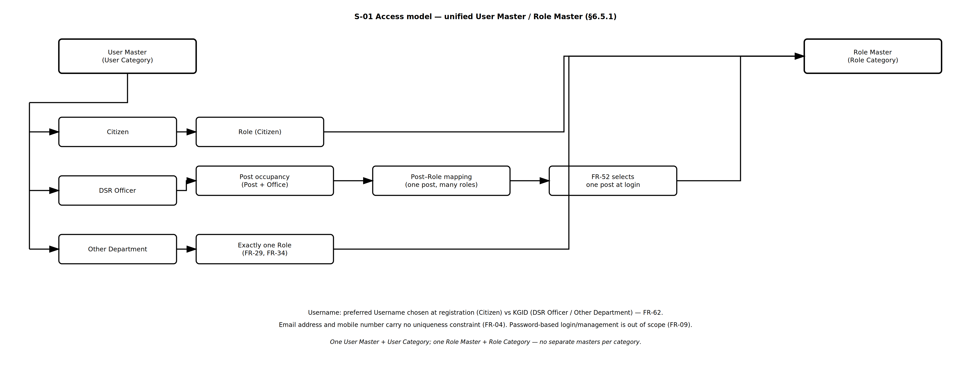
Figure — S-01 Access Model — FR-UM-004, FR-UM-009, FR-UM-029, FR-UM-034, FR-UM-052, FR-UM-062 — ProcessDiagrams/User_Management/S-01_Access_Model.drawio
Division Master (FR-UM-077):
DSR divisions are governed by the Division Master — not free text. Posts Master, Hierarchy Master, and role catalogues reference Division Code from this master.

Division Code | Division Name | Display Order | Status
DIV-SECRETARIAT | Secretariat | 1 | Active
DIV-TOP-MGMT | Top Management | 2 | Active
DIV-ADMIN | Admin, Law & Computers | 3 | Active
DIV-VIGILANCE | Vigilance | 4 | Active
DIV-COMPUTERS | Computers | 5 | Active
DIV-ENFORCEMENT | Enforcement | 6 | Active
DIV-INT-AUDIT | Intelligence & Audit | 7 | Active
DIV-CVC | DIGR CVC | 8 | Active
DSR roles in the Role Master (Role Category = DSR) are organised by division. Role names shall be unique (e.g. FDA (Admin), FDA (Enforcement) — not a single shared FDA). Summary:

Division (FR-UM-077) | Roles (Role Category = DSR) — unique names
DIV-SECRETARIAT | ACS / Principal Secretary / Secretary
DIV-TOP-MGMT | IGR
DIV-ADMIN | DIGR (Admin, Law & Computers), AIGR (Admin), HQA (Admin), Sub Registrar (Admin), FDA (Admin), SDA (Admin), Typist (Admin), HQA (RTI), FDA (RTI), SDA (RTI), Statistical Inspector, Accountant Superintendent (Admin)
DIV-VIGILANCE | DIGR (Vigilance), Law Officer
DIV-COMPUTERS | AIGR (Computers), System Integrator, PMU, Application Developer, HQA / Project Manager (Comp), Sub Registrar (Computers), FDA (Computers), SDA (Computers)
DIV-ENFORCEMENT | DIGR (Enforcement), DRO, HQA (Enforcement), Sub-Registrar (SR), FDA (Enforcement), SDA (Enforcement), DEO
DIV-INT-AUDIT | DIGR (Intelligence), AIGR (Audit), HQA (Audit), Superintendent (Audit), FDA (Audit), SDA (Audit), Typist (Audit)
DIV-CVC | DIGR CVC, JD Town Planning

6.5.2 User Categories and Authentication
All users are stored in the single User Master, differentiated by User Category. All user categories authenticate without passwords. Login uses the Username; the login OTP is sent only to the registered mobile. Captcha is required before OTP dispatch. The Username is a preferred Username chosen by the Citizen at registration, and the KGID for DSR Officers and Other Department users (FR-UM-062). The Username is the single unique login identifier across the whole User Master; email address and mobile number carry no uniqueness constraint (FR-UM-004). DSR Officers and Other Department users also verify Biometrics. Citizens may update their mobile after login (FR-UM-013) and may reset a lost mobile before login using three of five security questions plus a PIN to the registered email (FR-UM-056); departmental users have no self-service mobile reset and are served by an administrator instead (FR-UM-065). DSR Officers with multiple active post occupancies must select one post (with office details) after authentication before entering the application (FR-UM-052). After login they may take additional charge of a wholly unoccupied subordinate post at the same office without logout (FR-UM-053). The home/header shows the assigned Post with mapped Role(s) and any active additional charge (FR-UM-054). OTP and session rules are defined in FR-UM-069–FR-UM-076 (login OTP 5 minutes, idle timeout 15 minutes, one session per Username).
Terminology: Sub-Registrar Office (abbreviated SRO in Office Hierarchy) is an office type only. Role Master names use Sub Registrar (Admin) or Sub Registrar (Computers) — not SRO (Admin) or SRO (Comp) — to avoid confusion with the office abbreviation.
User Category | Username | Authentication | Lost-mobile reset
Public users (Citizens) — User Category = Public (Citizen) | Preferred Username chosen at registration (FR-UM-062) | Username + Captcha + OTP to mobile | Self-service: 3 of 5 security questions + PIN to registered email + OTP to new mobile (FR-UM-056)
Department users (DSR Officers) — User Category = DSR Officer | KGID (FR-UM-062, FR-UM-064) | Username (KGID) + Captcha + OTP to mobile + Biometrics; then FR-UM-052 | Not available — administrator changes mobile with reason and audit (FR-UM-065)
Other Department users — User Category = Other Department | KGID (FR-UM-062, FR-UM-064) | Username (KGID) + Captcha + OTP to mobile + Biometrics | Not available — administrator changes mobile with reason and audit (FR-UM-065)

6.5.2.1 Login — All User Categories (FR-UM-004–FR-UM-007, FR-UM-010, FR-UM-011, FR-UM-062)
Login uses the Username — the preferred Username for Citizens and the KGID for DSR Officers and Other Department users. Because the Username is unique across the whole User Master, the account is resolved unambiguously from the Username alone and no category selection is needed. The login OTP is never emailed; it is sent only by SMS to the registered mobile.

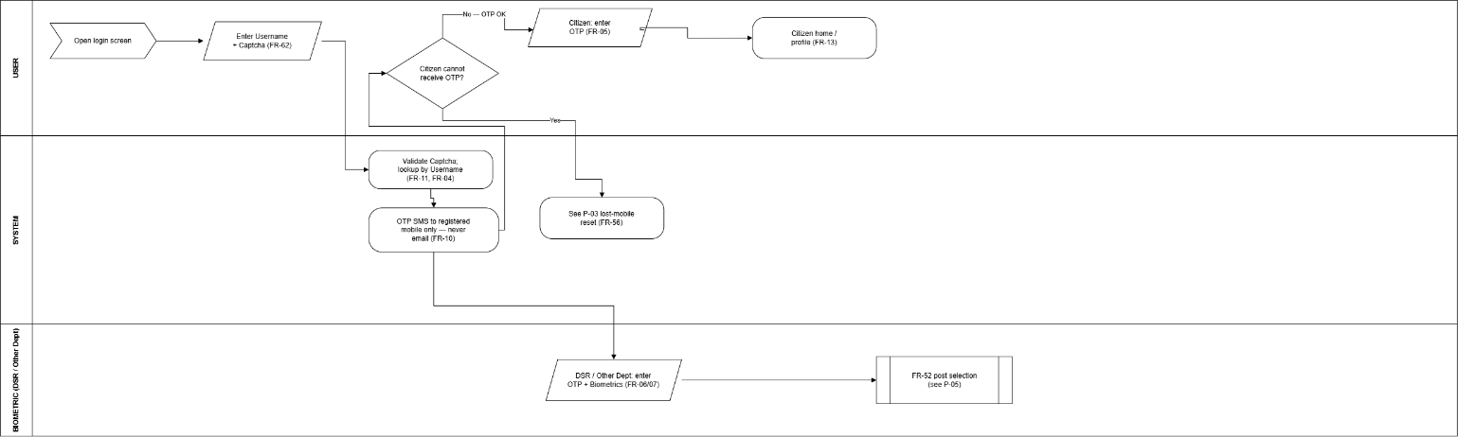

Step | Action | Actor / System | Notes
1 | Enter Username and Captcha | User | Citizen: preferred Username; DSR / Other Dept: KGID (FR-UM-062)
2 | Validate Captcha; look up the account by Username | System | FR-UM-011; Username unique across User Master (FR-UM-004)
3 | Dispatch login OTP to the registered mobile only | System | FR-UM-010; never to email
4 | Enter OTP (+ Biometrics for DSR / Other Department) | User | FR-UM-005 / FR-UM-006 / FR-UM-007
5 | If a Citizen cannot receive the OTP — leave login for lost-mobile reset | Citizen / System | FR-UM-056; Citizens only
6 | On success — enter home under assigned post (DSR: FR-UM-052 only at login) | System | Session established; FR-UM-053 available after login
7 | After login — Citizen may update mobile or email from profile | Citizen | FR-UM-013; departmental users via administrator (FR-UM-065)

6.5.2.2 Citizen Lost-Mobile Reset — Three of Five Questions Plus PIN to Registered Email (FR-UM-056)
This flow exists because the login OTP goes only to the registered mobile, so a citizen who has lost that number cannot otherwise log in. It requires two independent proofs before the mobile number can be changed: three security questions chosen at random from the five registered under FR-UM-055 (all three must be answered correctly, and the selection differs on each attempt), and a single-use PIN sent to the registered email address. The new mobile number is itself verified by OTP before the change takes effect. This flow is available only to Public users (Citizens).

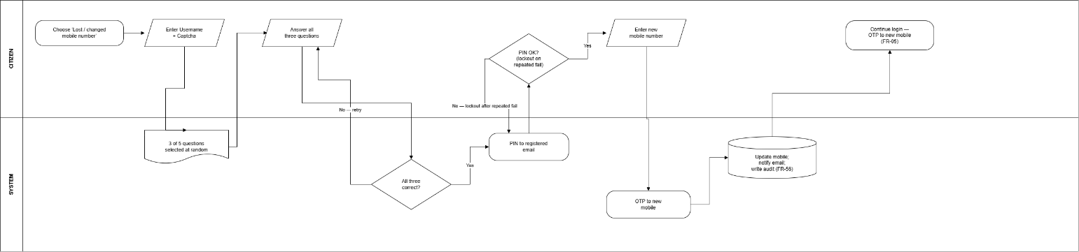

Step | Action | Actor / System | Notes
1 | On the login screen choose "Lost / changed mobile number" | Citizen | Offered to Citizens only (FR-UM-056, FR-UM-065)
2 | Enter Username and Captcha | Citizen | Username identifies the account (FR-UM-062)
3 | System selects three of the five registered security questions at random | System | Selection varies on each attempt (FR-UM-056)
4 | Answer all three questions | Citizen | All three must be correct; rate-limited
5 | On success — system sends a single-use, time-limited PIN to the registered email | System | Second independent factor (FR-UM-056)
6 | Enter the PIN | Citizen | Flow locked after configured failed attempts
7 | Enter the new mobile number | Citizen | Replaces the lost number
8 | System sends an OTP to the new mobile; citizen enters it | System / Citizen | Change takes effect only after this verification
9 | Update registered mobile; notify registered email; write audit log | System | FR-UM-056; actor, timestamp, old and new number (masked)
10 | Continue login with OTP to the new mobile | System | FR-UM-005

6.5.2.3 Departmental Mobile Change — Administrator Only, No Self-Service (FR-UM-065)
DSR Officers and Other Department users are not offered the FR-UM-056 reset path, and no security questions are held for them. A departmental user who has lost the registered mobile is served by an authorised administrator, who records a reason and whose action is audit-logged. This keeps the officer's authentication factors under departmental control and removes any pre-login route to redirect an officer's OTP.

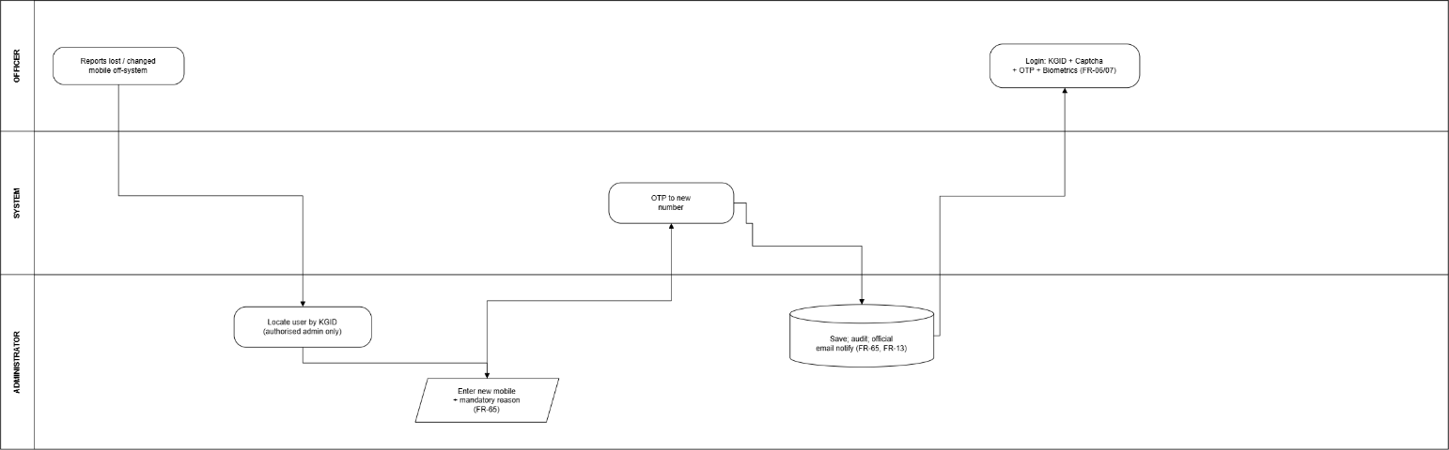

Step | Action | Actor / System | Notes
1 | Officer reports the lost / changed mobile to the authorised administrator | DSR / Other Dept user | Identity verified off-system per departmental procedure
2 | Administrator opens User Management and locates the user by KGID | Admin | Authorised admin role only (FR-UM-065)
3 | Administrator enters the new mobile number and a reason | Admin | Reason mandatory (FR-UM-065)
4 | System verifies the new number by OTP before saving | System / Officer | OTP to the new mobile
5 | Save — mobile updated; audit-logged; user notified on official email | System | FR-UM-065, FR-UM-013
6 | Officer logs in with Username (KGID) + Captcha + OTP to new mobile + Biometrics | Officer | FR-UM-006 / FR-UM-007

6.5.2.4 Login Post Selection — DSR Officers (FR-UM-052)
Applies only to DSR Officers. After Username (KGID) + Captcha + OTP (to mobile) + Biometrics succeed, the system loads the officer's active sanctioned-post occupancies. If more than one is active, the user must choose which post to work under for this session. Each choice shows Post Name and Office details so dual-charge / multi-office officers can pick the correct context.

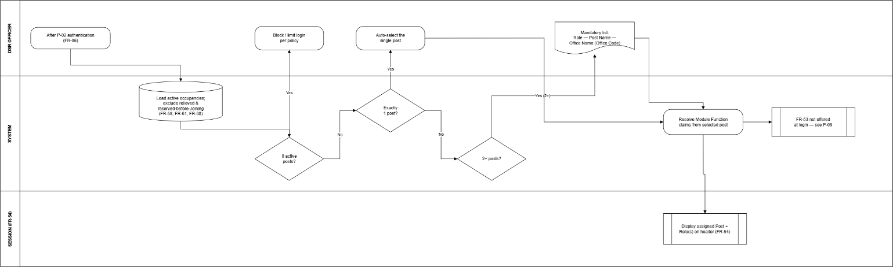

Step | Action | Actor / System | Notes
1 | Authenticate (Username (KGID) + Captcha + OTP to mobile + Biometrics) | DSR Officer / Auth | FR-UM-006
2 | Load active post occupancies (Post + Office) | System | Relieved / ended occupancies excluded; reserved Transfer In excluded until Joining Date (FR-UM-058, FR-UM-061, FR-UM-068)
3a | If exactly one active post — auto-select; continue to home | System | No selection UI; exclude posts before Joining Date 12:00 AM IST (FR-UM-061)
3b | If two or more active posts — show post selection list labelled Role — Post Name — Office Name (Office Code) | System / UI | Mandatory; cannot skip (FR-UM-052); only posts effective for login
4 | Display each option as Role — Post Name — Office Name (Office Code) | UI | Same unified label as FR-UM-052 / FR-UM-053 / FR-UM-054; Office details mandatory on each row
5 | User selects exactly one assigned post and confirms | DSR Officer | Assigned post stored on session (FR-UM-052)
6 | Resolve Module Function claims from assigned post; enter home | UM / Auth | FR-UM-038; FR-UM-053 not offered at login
7 | Display assigned Post with mapped Role(s) on home/header | UI | FR-UM-054

6.5.2.5 Additional Charge of Unoccupied Subordinate Post After Login (DSR Officers — FR-UM-053) and Display (FR-UM-054)
Additional charge is temporary in-office cover for a wholly unoccupied subordinate post — like holding an extra desk for the session — and does not require an order. It happens only after login under the assigned post (FR-UM-052), without logout. A subordinate post qualifies only when nobody is posted against it at that Office (Occupied = 0 — FR-UM-066(b)). While additional charge is active, session privileges derive from the additional charge post only — assigned-post privileges do not apply (FR-UM-038). At most one additional charge post may be active at a time; the officer may switch back to assigned-post context without logging out to restore assigned-post privileges.

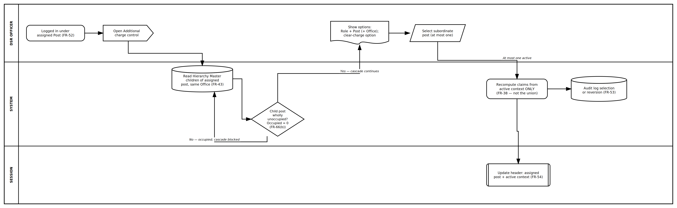

Step | Action | Actor / System | Notes
1 | Officer is logged in under assigned Post + Office (FR-UM-052) | DSR Officer / System | FR-UM-006, FR-UM-052
2 | From header or control — open Additional charge | DSR Officer / UI | Post-login only; no logout
3 | Read Hierarchy Master children of assigned Post at same Office | System | FR-UM-043
4 | List wholly unoccupied subordinate posts (cascade rules; FR-UM-066(b)) | System | Partial vacancy does not qualify
5 | Show options: Role + Post (+ Office); option to clear additional charge | UI | At most one additional charge active
6 | Officer selects subordinate post, switches back to assigned post, or clears additional charge | DSR Officer | No order required; one active context at a time
7 | Recompute Module Function claims for active context only — additional charge OR assigned post (FR-UM-038) | UM / Auth | SR acting as FDA loses SR signing until switch-back
8 | Update header — assigned post + active context label (FR-UM-054) | UI | Shows which context drives access
9 | Audit log selection or reversion | System | Mandatory (FR-UM-053)
Illustrative example (SR logged in at SRO Yeshwanthapura — additional charge after login). Only wholly unoccupied subordinate posts at the same Office (OFF-SRO-YESH) are offered (FR-UM-053); posts at other offices are never offered:

Office | Post under the login post (Sub-Registrar) | Sanctioned | Occupied | Offered for additional charge (FR-UM-053)? | Drop-down entry (Role — Post Name — Office Name (Office Code))
SRO Yeshwanthapura | Sub-Registrar (assigned post) | 1 | 1 (self) | Not applicable — assigned post is not additional charge | Assigned: Sub-Registrar (SR) — Sub-Registrar — SRO Yeshwanthapura (OFF-SRO-YESH)
SRO Yeshwanthapura | → FDA (Enforcement) | 2 | 1 | No — an FDA is posted, so the post is not unoccupied | Not listed
SRO Yeshwanthapura | → → SDA (Enforcement) under FDA | 1 | 0 | No — unreachable; the occupied FDA blocks the cascade | Not listed
SRO Yeshwanthapura | → Data Entry Operator | 2 | 0 | Yes — nobody is posted against it at this office | DEO — Data Entry Operator — SRO Yeshwanthapura (OFF-SRO-YESH)
SRO Jayanagar (different office) | → FDA (Enforcement) / SDA (Enforcement) | 2 / 1 | 0 / 0 | No — never offered; additional charge is same Office only (FR-UM-053). Empty posts at Jayanagar are occupancy facts for that office, not picker options here. | Not listed
After login — additional charge | — | — | — | SR may switch to additional charge as DEO — SR signing not available until switch-back (FR-UM-038) | Active context: Additional charge — DEO — Data Entry Operator — SRO Yeshwanthapura (OFF-SRO-YESH); switch back for SR privileges (FR-UM-054)

6.5.2.6 Assigned Post and Additional Charge Display (FR-UM-054)
On the home page and/or application header, the system shall always show the assigned Post Name, Office, and Role(s) from login (FR-UM-052). When additional charge is active, the header shall clearly indicate which context is driving session privileges — assigned post or additional charge post — while still showing the assigned post for reference. Example without additional charge: "Sub-Registrar (SR) — Sub-Registrar — SRO Yeshwanthapura (OFF-SRO-YESH)". Example with additional charge active: "Assigned: Sub-Registrar (SR) — Sub-Registrar — SRO Yeshwanthapura (OFF-SRO-YESH) | Active context: Additional charge — FDA (Enforcement) — FDA (Enforcement) — SRO Yeshwanthapura (OFF-SRO-YESH)". The officer opens the additional-charge control from here without logging out.

6.5.3 Posts Master, Post–Role Mapping, and Sanctioned Posts
Posts Master is separate from Role Master. Posts shall be division-specific where the organisation chart distinguishes them (FR-UM-049), so that Post–Role mapping does not over-provision access across Admin, Vigilance, and Enforcement. Sanctioned Posts Master references Posts Master (Post + Office + strength). Post–Role mapping links each Post to its corresponding unique Role(s). DSR Officers are assigned sanctioned posts that have available capacity; at login the officer selects one active post when multiple are assigned (FR-UM-052). Effective access follows the active context only: assigned post when no additional charge is active, or additional charge post when FR-UM-053 is active — not both simultaneously (FR-UM-038). Over-capacity assignment is blocked (FR-UM-026, FR-UM-027, FR-UM-045). FR-UM-066: assignment and Transfer In need available capacity (Occupied < Sanctioned Strength), except FR-UM-067 reservation against a recorded relieving; FR-UM-053 additional charge needs a wholly unoccupied post (Occupied = 0). Occupied counts are refreshed after midnight (FR-UM-068). Sanctioned posts must satisfy Post–Office-Type Allowed rules (FR-UM-078).
Posts Master — seed rows (division-specific; Division Code from Division Master — FR-UM-077):

Post Code | Post Name | Division Code (FR-UM-077) | Status
POST-ACS-SEC | Additional Chief Secretary / Principal Secretary / Secretary | DIV-SECRETARIAT | Active
POST-IGR | Inspector General of Registration & Commissioner of Stamps | DIV-TOP-MGMT | Active
POST-DIGR-ADMIN | DIGR (Admin, Law & Computers) | DIV-ADMIN | Active
POST-AIGR-ADMIN | AIGR (Admin) | DIV-ADMIN | Active
POST-HQA-ADMIN | HQA (Admin) | DIV-ADMIN | Active
POST-SR-ADMIN | Sub Registrar (Admin) | DIV-ADMIN | Active
POST-ACCT-SUP | Accountant Superintendent (Admin) | DIV-ADMIN | Active
POST-FDA-ADMIN | FDA (Admin) | DIV-ADMIN | Active
POST-SDA-ADMIN | SDA (Admin) | DIV-ADMIN | Active
POST-TYPIST-ADMIN | Typist (Admin) | DIV-ADMIN | Active
POST-HQA-RTI | HQA (RTI) | DIV-ADMIN | Active
POST-FDA-RTI | FDA (RTI) | DIV-ADMIN | Active
POST-SDA-RTI | SDA (RTI) | DIV-ADMIN | Active
POST-SI | Statistical Inspector | DIV-ADMIN | Active
POST-DIGR-VIG | DIGR (Vigilance) | DIV-VIGILANCE | Active
POST-LAW-OFF | Law Officer | DIV-VIGILANCE | Active
POST-AIGR-COMP | AIGR (Computers) | DIV-COMPUTERS | Active
POST-SI-INT | System Integrator | DIV-COMPUTERS | Active
POST-APP-DEV | Application Developer | DIV-COMPUTERS | Active
POST-PMU | PMU | DIV-COMPUTERS | Active
POST-HQA-COMP | HQA / Project Manager (Comp) | DIV-COMPUTERS | Active
POST-SR-COMP | Sub Registrar (Computers) | DIV-COMPUTERS | Active
POST-FDA-COMP | FDA (Computers) | DIV-COMPUTERS | Active
POST-SDA-COMP | SDA (Computers) | DIV-COMPUTERS | Active
POST-DIGR-ENF | DIGR (Enforcement) | DIV-ENFORCEMENT | Active
POST-DRO | District Registrar | DIV-ENFORCEMENT | Active
POST-HQA-ENF | HQA (Enforcement) | DIV-ENFORCEMENT | Active
POST-SR | Sub-Registrar | DIV-ENFORCEMENT | Active
POST-FDA-ENF | FDA (Enforcement) | DIV-ENFORCEMENT | Active
POST-SDA-ENF | SDA (Enforcement) | DIV-ENFORCEMENT | Active
POST-DEO | Data Entry Operator | DIV-ENFORCEMENT | Active
POST-DIGR-INT | DIGR (Intelligence) | DIV-INT-AUDIT | Active
POST-AIGR-AUDIT | AIGR (Audit) | DIV-INT-AUDIT | Active
POST-HQA-AUDIT | HQA (Audit) | DIV-INT-AUDIT | Active
POST-SUP-AUDIT | Superintendent (Audit) | DIV-INT-AUDIT | Active
POST-FDA-AUDIT | FDA (Audit) | DIV-INT-AUDIT | Active
POST-SDA-AUDIT | SDA (Audit) | DIV-INT-AUDIT | Active
POST-TYPIST-AUDIT | Typist (Audit) | DIV-INT-AUDIT | Active
POST-DIGR-CVC | DIGR CVC | DIV-CVC | Active
POST-JD-TP | JD Town Planning | DIV-CVC | Active
Post–Role mapping — seed rows for all active Posts (division-aligned; avoid cross-division over-provisioning). Post Name must match Posts Master character-for-character (FR-UM-050). FR-UM-047 blocks sanction or assignment of any Post with no mapping row:

Post Code | Post Name | Mapped Role (unique name) | Notes
POST-ACS-SEC | Additional Chief Secretary / Principal Secretary / Secretary | ACS / Principal Secretary / Secretary | 1:1 — hierarchy root; sanctioned at MS Building
POST-IGR | Inspector General of Registration & Commissioner of Stamps | IGR | 1:1
POST-DIGR-ADMIN | DIGR (Admin, Law & Computers) | DIGR (Admin, Law & Computers) | Not mapped to Vigilance/Enforcement DIGR roles
POST-AIGR-ADMIN | AIGR (Admin) | AIGR (Admin) | 1:1
POST-HQA-ADMIN | HQA (Admin) | HQA (Admin) | 1:1
POST-SR-ADMIN | Sub Registrar (Admin) | Sub Registrar (Admin) | 1:1
POST-ACCT-SUP | Accountant Superintendent (Admin) | Accountant Superintendent (Admin) | 1:1
POST-FDA-ADMIN | FDA (Admin) | FDA (Admin) | Unique role — not shared FDA
POST-SDA-ADMIN | SDA (Admin) | SDA (Admin) | Unique role
POST-TYPIST-ADMIN | Typist (Admin) | Typist (Admin) | 1:1
POST-HQA-RTI | HQA (RTI) | HQA (RTI) | 1:1
POST-FDA-RTI | FDA (RTI) | FDA (RTI) | 1:1
POST-SDA-RTI | SDA (RTI) | SDA (RTI) | 1:1
POST-SI | Statistical Inspector | Statistical Inspector | 1:1
POST-DIGR-VIG | DIGR (Vigilance) | DIGR (Vigilance) | 1:1 — division-specific
POST-LAW-OFF | Law Officer | Law Officer | 1:1
POST-AIGR-COMP | AIGR (Computers) | AIGR (Computers) | 1:1
POST-SI-INT | System Integrator | System Integrator | 1:1
POST-APP-DEV | Application Developer | Application Developer | 1:1
POST-PMU | PMU | PMU | 1:1
POST-HQA-COMP | HQA / Project Manager (Comp) | HQA / Project Manager (Comp) | 1:1
POST-SR-COMP | Sub Registrar (Computers) | Sub Registrar (Computers) | 1:1 — Post Name matches Role
POST-FDA-COMP | FDA (Computers) | FDA (Computers) | 1:1
POST-SDA-COMP | SDA (Computers) | SDA (Computers) | 1:1
POST-DIGR-ENF | DIGR (Enforcement) | DIGR (Enforcement) | 1:1 — division-specific
POST-DRO | District Registrar | DRO | 1:1
POST-HQA-ENF | HQA (Enforcement) | HQA (Enforcement) | 1:1
POST-SR | Sub-Registrar | Sub-Registrar (SR) | Field signing post
POST-FDA-ENF | FDA (Enforcement) | FDA (Enforcement) | Unique role
POST-SDA-ENF | SDA (Enforcement) | SDA (Enforcement) | Unique role
POST-DEO | Data Entry Operator | DEO | 1:1
POST-DIGR-INT | DIGR (Intelligence) | DIGR (Intelligence) | 1:1
POST-AIGR-AUDIT | AIGR (Audit) | AIGR (Audit) | 1:1
POST-HQA-AUDIT | HQA (Audit) | HQA (Audit) | 1:1
POST-SUP-AUDIT | Superintendent (Audit) | Superintendent (Audit) | 1:1
POST-FDA-AUDIT | FDA (Audit) | FDA (Audit) | Unique role
POST-SDA-AUDIT | SDA (Audit) | SDA (Audit) | 1:1
POST-TYPIST-AUDIT | Typist (Audit) | Typist (Audit) | 1:1
POST-DIGR-CVC | DIGR CVC | DIGR CVC | 1:1
POST-JD-TP | JD Town Planning | JD Town Planning | 1:1
Sanctioned Posts Master — references Posts Master (example rows; the last two columns show the two distinct vacancy tests of FR-UM-066 — note that FDA (Enforcement) at SRO Yeshwanthapura has capacity for another appointment yet is not available for FR-UM-053 acting):

Office Code | Office Name | Post Code | Post Name | Sanctioned Strength | Occupied | Vacancies remaining | Available capacity — FR-UM-066(a) | Wholly unoccupied — FR-UM-066(b)
OFF-MS-BLDG | MS Building | POST-ACS-SEC | Additional Chief Secretary / Principal Secretary / Secretary | 1 | 1 | 0 | No — full | No
OFF-SRO-YESH | SRO Yeshwanthapura | POST-SR | Sub-Registrar | 1 | 1 | 0 | No — full | No
OFF-SRO-YESH | SRO Yeshwanthapura | POST-FDA-ENF | FDA (Enforcement) | 2 | 1 | 1 | Yes — may assign one more | No — an FDA is posted
OFF-SRO-YESH | SRO Yeshwanthapura | POST-SDA-ENF | SDA (Enforcement) | 1 | 0 | 1 | Yes | Yes
OFF-SRO-YESH | SRO Yeshwanthapura | POST-DEO | Data Entry Operator | 2 | 0 | 2 | Yes | Yes
OFF-SRO-JAY | SRO Jayanagar | POST-FDA-ENF | FDA (Enforcement) | 2 | 0 | 2 | Yes | Yes
OFF-SRO-JAY | SRO Jayanagar | POST-SDA-ENF | SDA (Enforcement) | 1 | 0 | 1 | Yes | Yes
OFF-DRO-MYS | DRO Mysuru | POST-DRO | District Registrar | 1 | 1 | 0 | No — full | No
OFF-DRO-MYS | DRO Mysuru | POST-HQA-ENF | HQA (Enforcement) | 1 | 0 | 1 | Yes | Yes
OFF-IGR | IGR Office (Head Office) | POST-DIGR-ADMIN | DIGR (Admin, Law & Computers) | 1 | 1 | 0 | No — full | No
OFF-IGR | IGR Office (Head Office) | POST-DIGR-ENF | DIGR (Enforcement) | 1 | 0 | 1 | Yes | Yes
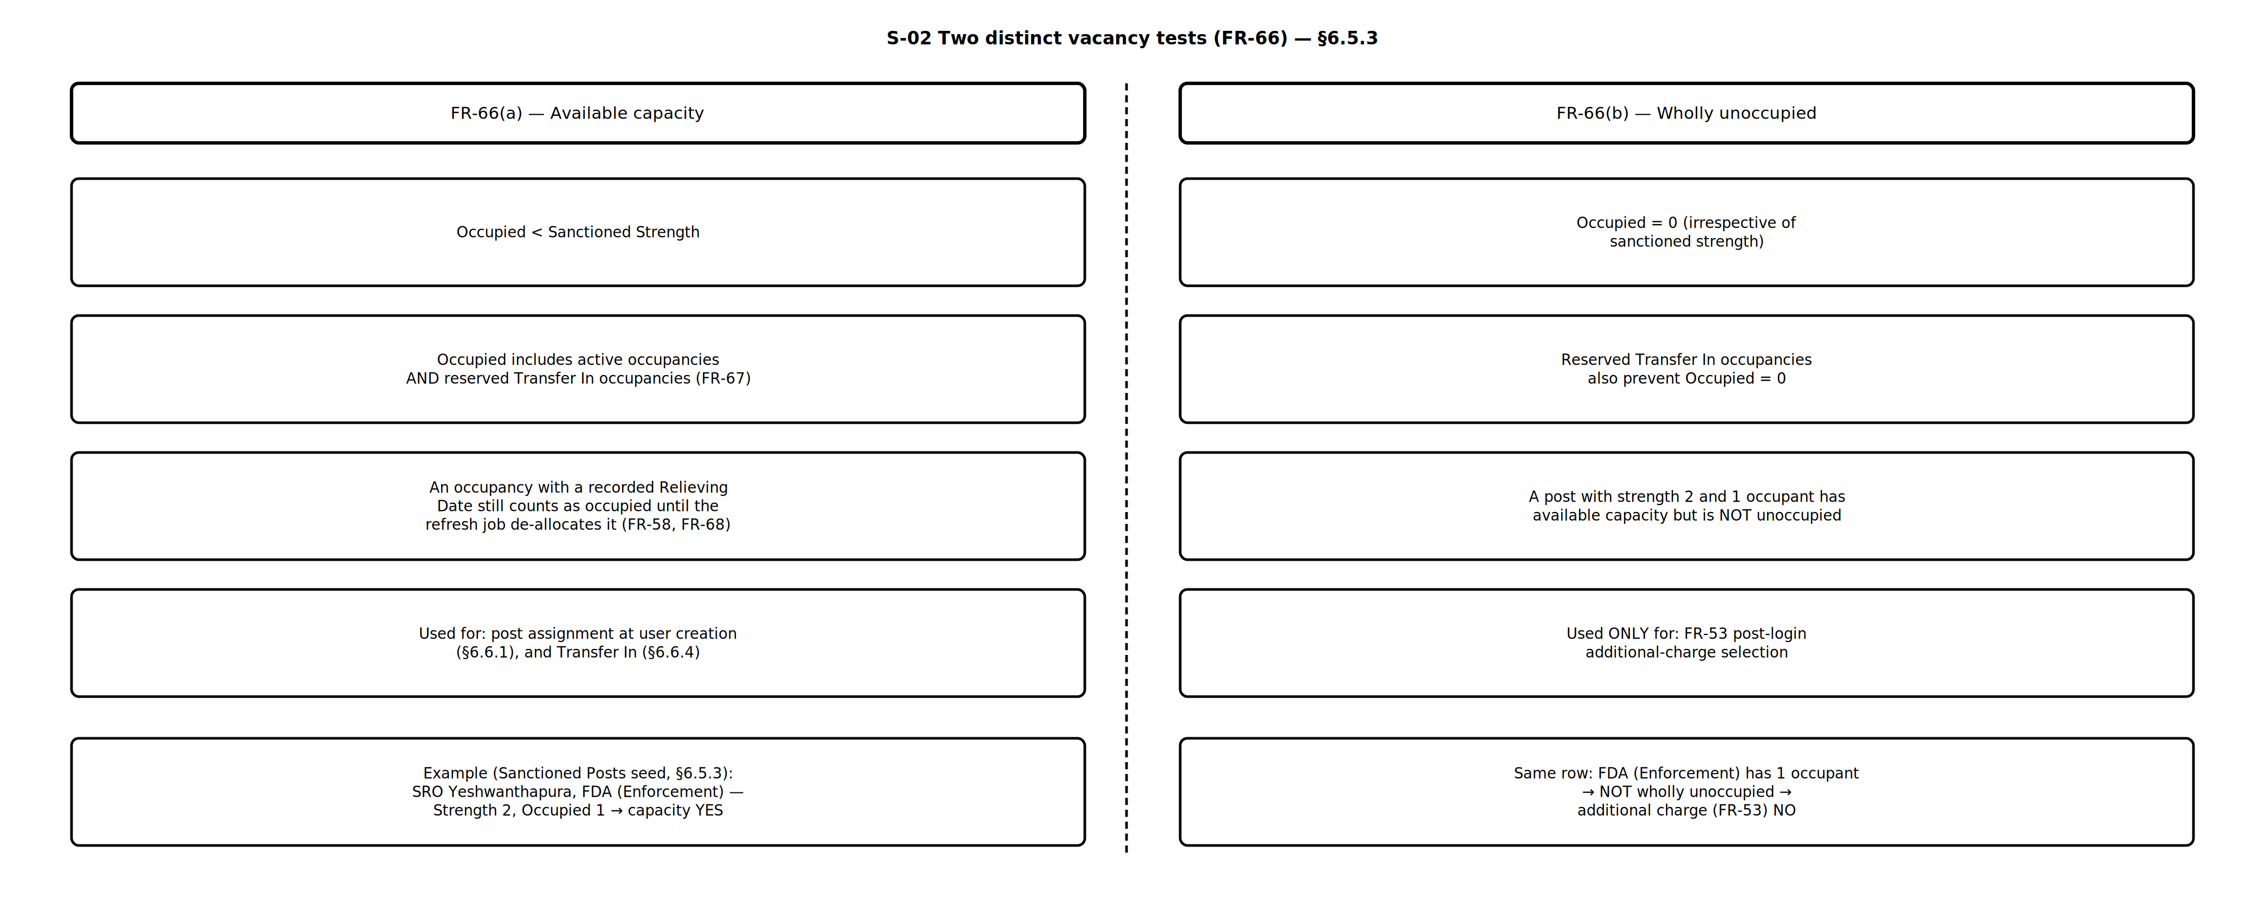
Figure — S-02 Two Vacancy Tests — FR-UM-066 — ProcessDiagrams/User_Management/S-02_Two_Vacancy_Tests.drawio
Post–Office-Type Allowed mapping — seed rows for all active Posts (FR-UM-078):

Post Code | Allowed Office Type(s) | Notes
POST-ACS-SEC | Secretariat | ACS / Secretary at MS Building only
POST-IGR | Head Office | IGR at IGR Office
POST-DIGR-ADMIN | Head Office | Admin DIGR
POST-AIGR-ADMIN | Head Office | Admin AIGR
POST-HQA-ADMIN | Head Office | Admin HQ
POST-SR-ADMIN | Head Office | Admin Sub Registrar
POST-ACCT-SUP | Head Office | Admin accounts
POST-FDA-ADMIN | Head Office | Admin FDA
POST-SDA-ADMIN | Head Office | Admin SDA
POST-TYPIST-ADMIN | Head Office | Admin Typist
POST-HQA-RTI | Head Office | RTI HQ
POST-FDA-RTI | Head Office | RTI FDA
POST-SDA-RTI | Head Office | RTI SDA
POST-SI | Head Office | Statistical Inspector
POST-DIGR-VIG | Head Office | Vigilance DIGR
POST-LAW-OFF | Head Office | Law Officer
POST-AIGR-COMP | Head Office | Computers AIGR
POST-SI-INT | Head Office | System Integrator
POST-APP-DEV | Head Office | Application Developer
POST-PMU | Head Office | PMU
POST-HQA-COMP | Head Office | Computers HQ / PM
POST-SR-COMP | Head Office | Sub Registrar (Computers)
POST-FDA-COMP | Head Office | Computers FDA
POST-SDA-COMP | Head Office | Computers SDA
POST-DIGR-ENF | Head Office | Enforcement DIGR
POST-DRO | District Registrar Office | District Registrar only at DRO
POST-HQA-ENF | District Registrar Office, Head Office | Enforcement HQA at DRO or Head Office
POST-SR | Sub-Registrar Office | Field Sub-Registrar
POST-FDA-ENF | Sub-Registrar Office | Enforcement FDA at SRO
POST-SDA-ENF | Sub-Registrar Office | Enforcement SDA at SRO
POST-DEO | Sub-Registrar Office | Data Entry Operator at SRO
POST-DIGR-INT | Head Office | Intelligence DIGR
POST-AIGR-AUDIT | Head Office | Audit AIGR
POST-HQA-AUDIT | Head Office | Audit HQ
POST-SUP-AUDIT | Head Office | Superintendent (Audit)
POST-FDA-AUDIT | Head Office | Audit FDA
POST-SDA-AUDIT | Head Office | Audit SDA
POST-TYPIST-AUDIT | Head Office | Audit Typist
POST-DIGR-CVC | Head Office | DIGR CVC
POST-JD-TP | Head Office | JD Town Planning
Application Admin maintenance:

Master / Table | Application Admin may | FR
Posts Master | Add, edit, enable/disable posts; Division Code from Division Master (FR-UM-077) | FR-UM-046, FR-UM-077
Division Master | Add, edit, enable/disable divisions | FR-UM-077
Post–Role mapping | Map one Post to one or more Roles; block sanction/assignment if unmapped (FR-UM-047) | FR-UM-047
Post–Office-Type Allowed mapping | Define which Post codes may be sanctioned at which Office Types | FR-UM-078
Sanctioned Posts Master | Set strength per Post per Office (Office Code); validate Office Type; view occupied count (including reserved Transfer In), remaining capacity, and whether the post is wholly unoccupied; occupied counts updated by occupancy refresh job | FR-UM-024, FR-UM-025, FR-UM-048, FR-UM-067, FR-UM-068, FR-UM-078

6.5.4 Role Master — Seed Roles by Role Category
All roles below reside in the single Role Master, differentiated by Role Category. Seed roles are listed for Citizen, Other Department, and DSR (Department). Application Admin may add further roles under the same Role Categories. Other Department users are assigned exactly one role with Role Category = Other Department. DSR Officers receive roles only through Post–Role mapping after sanctioned post assignment. Sanctioned posts reference Posts Master and apply only to DSR establishment posts.
Roles with Role Category = Citizen:

Role | Description
Citizen | Default role assigned on instant self-registration; access to citizen portal services
Marriage Applicant | Apply for Hindu Marriage / Special Marriage registration and related citizen actions
Document Registration Applicant | Initiate and track document registration applications
Certified Copy / EC Applicant | Apply for Encumbrance Certificate (EC) and certified copy of registered documents
Firm / Society Applicant | Apply for firm / society related registration services where offered on the portal
Stamp Duty / Challan Payer | Pay stamp duty / registration fees and view payment history for citizen transactions
Roles with Role Category = Other Department:

Role | Typical Parent Department | Description
Revenue Verification Officer | Revenue | Verify land / revenue particulars linked to registration applications
Bhoomi Cross-check User | Revenue | Cross-check Bhoomi / RTC data against registration records
Treasury Payment Verifier | Treasury / Finance | Verify treasury / payment status for registration fees
Khajane Reconciliation User | Treasury / Finance | Reconcile Khajane-II receipts with Kaveri transactions
Police Enquiry Officer | Police | View / respond to police enquiry requests on registered documents
FIR Verification User | Police | Verify FIR / crime particulars where required for registration workflow
ULB Document Verifier | Urban Local Body (ULB) | Verify municipal / ULB documents submitted with applications
Read-only MIS Viewer | Any (cross-department) | Read-only access to assigned MIS / dashboards; no transactional actions
Document Upload User | Any (cross-department) | Upload supporting documents for assigned inter-department workflows
Inter-Department Enquiry User | Any (cross-department) | Raise / respond to inter-department enquiries on applications
Roles with Role Category = DSR (Department) — unique role names (no duplicate FDA/SDA/Typist):

Division Code (FR-UM-077) | Role (unique name) | Description
DIV-SECRETARIAT | ACS / Principal Secretary / Secretary | Additional Chief Secretary / Principal Secretary / Secretary — hierarchy root
DIV-TOP-MGMT | IGR | Inspector General of Registration & Commissioner of Stamps
DIV-ADMIN | DIGR (Admin, Law & Computers) | Deputy IGR for Admin, Law & Computers
DIV-ADMIN | AIGR (Admin) | Assistant IGR (Admin)
DIV-ADMIN | HQA (Admin) | Head Quarter Assistant (Admin)
DIV-ADMIN | Sub Registrar (Admin) | Sub Registrar (Admin) — not to be confused with Sub-Registrar Office (SRO) office type
DIV-ADMIN | Accountant Superintendent (Admin) | Accountant Superintendent (Admin)
DIV-ADMIN | FDA (Admin) | First Division Assistant — Admin
DIV-ADMIN | SDA (Admin) | Second Division Assistant — Admin
DIV-ADMIN | Typist (Admin) | Typist — Admin
DIV-ADMIN | HQA (RTI) | Head Quarter Assistant (RTI)
DIV-ADMIN | FDA (RTI) | First Division Assistant — RTI & Statistics
DIV-ADMIN | SDA (RTI) | Second Division Assistant — RTI & Statistics
DIV-ADMIN | Statistical Inspector | Statistical Inspector
DIV-VIGILANCE | DIGR (Vigilance) | Deputy IGR (Vigilance)
DIV-VIGILANCE | Law Officer | Departmental Law Officer
DIV-COMPUTERS | AIGR (Computers) | Assistant IGR (Computers)
DIV-COMPUTERS | System Integrator | System Integrator / SI support
DIV-COMPUTERS | PMU | Project Management Unit
DIV-COMPUTERS | Application Developer | Application development support
DIV-COMPUTERS | HQA / Project Manager (Comp) | Head Quarter Assistant / Project Manager (Computers)
DIV-COMPUTERS | Sub Registrar (Computers) | Sub Registrar (Computers)
DIV-COMPUTERS | FDA (Computers) | First Division Assistant — Computers
DIV-COMPUTERS | SDA (Computers) | Second Division Assistant — Computers
DIV-ENFORCEMENT | DIGR (Enforcement) | Deputy IGR (Enforcement)
DIV-ENFORCEMENT | DRO | District Registrar / DRO
DIV-ENFORCEMENT | HQA (Enforcement) | Head Quarter Assistant (Enforcement)
DIV-ENFORCEMENT | Sub-Registrar (SR) | Sub-Registrar (office head / signing)
DIV-ENFORCEMENT | FDA (Enforcement) | First Division Assistant — Enforcement
DIV-ENFORCEMENT | SDA (Enforcement) | Second Division Assistant — Enforcement
DIV-ENFORCEMENT | DEO | Data Entry Operator — SRO operational role
DIV-INT-AUDIT | DIGR (Intelligence) | Deputy IGR (Intelligence)
DIV-INT-AUDIT | AIGR (Audit) | Assistant IGR (Audit)
DIV-INT-AUDIT | HQA (Audit) | Head Quarter Assistant (Audit)
DIV-INT-AUDIT | Superintendent (Audit) | Superintendent (Audit)
DIV-INT-AUDIT | FDA (Audit) | First Division Assistant — Audit
DIV-INT-AUDIT | SDA (Audit) | Second Division Assistant — Audit
DIV-INT-AUDIT | Typist (Audit) | Typist — Audit
DIV-CVC | DIGR CVC | Deputy IGR (CVC)
DIV-CVC | JD Town Planning | Joint Director, Town Planning

6.5.5 DSR Officer Post Assignment
DSR Officers are assigned one or more sanctioned posts that have available capacity (Posts Master via Sanctioned Posts Master). There is no Primary or Secondary role/post assignment. At login, if multiple active posts exist, the officer selects one post shown with office details (FR-UM-052); session roles = roles mapped to the assigned post at login; may take additional charge of a wholly unoccupied subordinate after login without logout (FR-UM-053, FR-UM-038). Division-specific posts prevent over-provisioning across Admin/Vigilance/Enforcement (FR-UM-047, FR-UM-049). Other Department users and Citizens use Role Master directly (see Sections 6.5.1, 6.5.4 and 6.6.2).

User Category | What is assigned | Roles in session | End Date | Notes
DSR Officer | One or more sanctioned posts with available capacity (Post + Office) — FR-UM-066(a) | Active context: assigned post (FR-UM-052) or additional charge (FR-UM-053) — one at a time per FR-UM-038 | Optional per post occupancy | Multi-post → choose assigned post at login; switch context after login without logout
Other Department | Exactly one role from Role Master | That single role | Optional account End Date | No Posts Master / sanctioned posts
Citizen | Citizen role(s) from Role Master (e.g. on self-registration) | Assigned Citizen role(s) | N/A | No sanctioned posts

6.5.6 Module, Function, Resource Masters and Access Enforcement
DSR organisational roles (SR, FDA (Enforcement), DEO, etc.) are not named after application services. Access is modelled as: User → Role(s) → Module Function(s) → Resource(s) (API/URL). Registration of Documents is a single module (no online/offline classification). Role names in Role–Module–Function mapping must match Role Master exactly (FR-UM-050). Application Admin is a system-level actor outside Role Master / Role–Module–Function mapping (FR-UM-051) and maintains all masters in this section (FR-UM-042). Maker-checker / dual authorisation is not required. DSR and Other Department user creation does not capture security questions.
Privilege hierarchy (masters):

Level | Master | Maintained by | Purpose
1 | Module Master | Application Admin | Business modules (Registration of Documents, Marriage Registration, …)
2 | Module Function Master | Application Admin | Functions under each module (VIEW, ADD, APPROVE, SIGN, …)
3 | Resource Master | Application Admin | APIs and URLs linked to each Module Function
4 | Role–Module–Function mapping | Application Admin | Which roles may perform which Module Functions
Module Master — seed rows:

Module Code | Module Name | Description | Status
MOD-DOC-REG | Registration of Documents | Registration of documents | Active
MOD-MARRIAGE | Marriage Registration | Marriage registration (Hindu Marriage and Special Marriage) | Active
MOD-EC | Encumbrance Search | Search and issue of Encumbrance Certificate (EC) | Active
MOD-CC | Certified Copy | Application and issue of certified copies of registered documents | Active
MOD-STAMP | Stamp Duty / Payments | Stamp duty assessment, challan, and payment reconciliation | Active
MOD-FIRM | Firm / Society Registration | Firm and society related registration services | Active
MOD-UM | User Management | Identity, roles, posts, modules, functions, resources, and mappings | Active
MOD-MIS | MIS / Dashboards | Operational and management reporting | Active
Module Function Master — example rows:

Function Code | Module | Function Name | Description
FN-DOC-VIEW | Registration of Documents | VIEW | View document registration applications / records
FN-DOC-ADD | Registration of Documents | ADD | Create / initiate document registration
FN-DOC-EDIT | Registration of Documents | EDIT | Edit draft / in-progress applications
FN-DOC-APPROVE | Registration of Documents | APPROVE | Approve application for registration
FN-DOC-SIGN | Registration of Documents | SIGN | Digitally sign registered document
FN-DOC-PRINT | Registration of Documents | PRINT | Print registration extracts / slips
FN-MAR-VIEW | Marriage Registration | VIEW | View marriage applications
FN-MAR-ADD | Marriage Registration | ADD | Create marriage application
FN-MAR-APPROVE | Marriage Registration | APPROVE | Approve / register marriage
FN-EC-APPLY | Encumbrance Search | APPLY | Apply for EC
FN-EC-ISSUE | Encumbrance Search | ISSUE | Issue / download EC
FN-CC-APPLY | Certified Copy | APPLY | Apply for certified copy
FN-CC-ISSUE | Certified Copy | ISSUE | Issue / download certified copy
FN-UM-ADMIN | User Management | ADMIN | Maintain users, roles, modules, functions, resources, mappings
Resource Master (API / URL) — example rows:

Resource Code | Type | Method | Path / URL Pattern | Module Function | Is Public | Status
RES-DOC-GET | API | GET | /api/v1/documents/{id} | FN-DOC-VIEW | No | Active
RES-DOC-LIST | API | GET | /api/v1/documents | FN-DOC-VIEW | No | Active
RES-DOC-CREATE | API | POST | /api/v1/documents | FN-DOC-ADD | No | Active
RES-DOC-UPDATE | API | PUT | /api/v1/documents/{id} | FN-DOC-EDIT | No | Active
RES-DOC-APPROVE | API | POST | /api/v1/documents/{id}/approve | FN-DOC-APPROVE | No | Active
RES-DOC-SIGN | API | POST | /api/v1/documents/{id}/sign | FN-DOC-SIGN | No | Active
RES-UI-DOC-VIEW | URL | GET | /app/documents/view | FN-DOC-VIEW | No | Active
RES-UI-DOC-CREATE | URL | GET | /app/documents/create | FN-DOC-ADD | No | Active
RES-MAR-CREATE | API | POST | /api/v1/marriages | FN-MAR-ADD | No | Active
RES-MAR-APPROVE | API | POST | /api/v1/marriages/{id}/approve | FN-MAR-APPROVE | No | Active
RES-EC-APPLY | API | POST | /api/v1/encumbrance/applications | FN-EC-APPLY | No | Active
RES-CC-ISSUE | API | POST | /api/v1/certified-copies/{id}/issue | FN-CC-ISSUE | No | Active
RES-UM-ROLES | API | PUT | /api/v1/admin/roles/{id}/module-functions | FN-UM-ADMIN | No | Active
RES-PUBLIC-HEALTH | API | GET | /api/v1/public/health | — | Yes | Active
Resource Master attributes (Application Admin maintains):
Attribute | Description | Mandatory
Resource Code | System or admin-defined unique identifier | Yes
Type | API or URL | Yes
HTTP Method | GET, POST, PUT, DELETE, … (for APIs) | Yes for API
Path / URL Pattern | Ant-style or regex path pattern matched at runtime | Yes
Module Function | Required function code for non-public resources (FR-UM-041) | Yes unless Is Public
Is Public | Yes = accessible without authentication; default No (deny-by-default) | Yes
Match Precedence | When multiple patterns match, most specific (longest) pattern wins | System rule (FR-UM-041)
Is Active | Enable / disable resource without deleting history | Yes
Role–Module–Function mapping — example rows (exact Role Master names only; FR-UM-050):
Every Role column value must match an active Role Master name character-for-character. Document-registration functions for First Division Assistants are seeded for FDA (Enforcement) only (Enforcement / SRO document-registration path). FDA (Admin), FDA (RTI), FDA (Computers), and FDA (Audit) are not granted these functions unless Domain Expert adds explicit separate rows. Sub-Registrar (SR) and DEO match 6.5.4 unchanged. Application Admin is not listed here (FR-UM-051).

Role | Role Category | Module Function | Allowed
Citizen | Citizen | FN-DOC-ADD | Yes
Citizen | Citizen | FN-DOC-VIEW | Yes
Citizen | Citizen | FN-EC-APPLY | Yes
Citizen | Citizen | FN-CC-APPLY | Yes
Document Registration Applicant | Citizen | FN-DOC-ADD | Yes
Document Registration Applicant | Citizen | FN-DOC-VIEW | Yes
Sub-Registrar (SR) | DSR | FN-DOC-VIEW | Yes
Sub-Registrar (SR) | DSR | FN-DOC-APPROVE | Yes
Sub-Registrar (SR) | DSR | FN-DOC-SIGN | Yes
Sub-Registrar (SR) | DSR | FN-DOC-PRINT | Yes
Sub-Registrar (SR) | DSR | FN-MAR-APPROVE | Yes
DEO | DSR | FN-DOC-VIEW | Yes
DEO | DSR | FN-DOC-ADD | Yes
DEO | DSR | FN-DOC-EDIT | Yes
DEO | DSR | FN-MAR-ADD | Yes
FDA (Enforcement) | DSR | FN-DOC-VIEW | Yes
FDA (Enforcement) | DSR | FN-DOC-ADD | Yes
FDA (Enforcement) | DSR | FN-DOC-EDIT | Yes
Revenue Verification Officer | Other Department | FN-DOC-VIEW | Yes
Application Admin (system actor — Option B): Application Admin is not a Role Master seed role and is not assigned via sanctioned posts or the normal user-creation flow. It is seeded at deployment as a system principal with authority to maintain User Management masters (Module, Module Function, Resource, Role–Module–Function, Posts, Hierarchy, Sanctioned Posts, etc.). FN-UM-ADMIN and related Resource Master rows (e.g. RES-UM-ROLES) describe the capability surface for that principal; they are not granted through a Role–Module–Function mapping row labelled Application Admin | DSR (FR-UM-051).
How the application enforces access (runtime):

Step | Action | Actor / Component | Notes
1 | User authenticates (Username + Captcha + OTP to mobile; + Biometrics if DSR/Other Dept) | User / Auth service | Username = preferred Username (Citizen) or KGID (departmental) — FR-UM-062
1a | If DSR Officer with multiple active posts — select assigned Post + Office for session | User / UI | Mandatory at login only (FR-UM-052)
1b | Show assigned Post with Role(s); offer Additional charge control after login | UI | FR-UM-054, FR-UM-053; no logout to switch
2 | Load session role(s) for active context — assigned post OR additional charge post | Auth / UM service | One context at a time per FR-UM-038
3 | Resolve Role–Module–Function mappings into session claims (function codes) | UM / Auth service | Functions for session roles (FR-UM-038)
4 | User calls an API or opens a URL | Client / Browser | Method + path
5 | Look up Resource Master for matching Type + Method + Path pattern (most specific wins) | API Gateway / Middleware | If no match → deny (403) unless Is Public = Yes (FR-UM-041)
6 | Obtain required Module Function from the matched Resource | API Gateway / Middleware | e.g. POST /api/v1/documents/{id}/approve → FN-DOC-APPROVE
7 | Allow if session claims include that Module Function; else HTTP 403 | API Gateway / Middleware | FR-UM-041; Application Admin system principal may hold FN-UM-ADMIN outside mapping (FR-UM-051); failed attempts audit-logged
8 | UI menus / buttons shown only for Module Functions present in session claims | Front-end | Same mapping; hide unauthorised screens
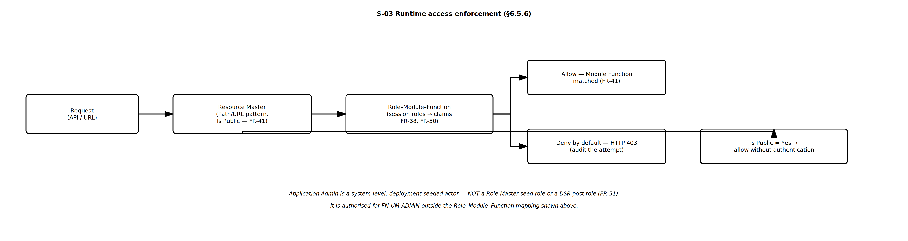
Figure — S-03 Runtime Enforcement — FR-UM-038, FR-UM-041, FR-UM-050, FR-UM-051 — ProcessDiagrams/User_Management/S-03_Runtime_Enforcement.drawio
Application Admin maintenance (CRUD):

Master / Table | Application Admin may | Audit
Module Master | Add, edit, enable/disable modules | Mandatory (FR-UM-042)
Module Function Master | Add, edit, enable/disable functions under a module | Mandatory (FR-UM-042)
Resource Master | Add, edit, enable/disable API and URL resources; link to Module Function | Mandatory (FR-UM-042)
Role–Module–Function mapping | Grant or revoke Module Functions for Role Master roles only (exact names; FR-UM-050); not used for Application Admin (FR-UM-051) | Mandatory (FR-UM-042)
DSR Officer Hierarchy Master | Add, edit, reorder, enable/disable hierarchy nodes (6.5.7) | Mandatory (FR-UM-043)
Office Hierarchy Master | Add, edit, enable/disable offices; set parent (IGR → DRO → SRO) (6.5.8) | Mandatory (FR-UM-059)

6.5.7 DSR Officer Hierarchy Master
The system shall maintain the reporting hierarchy for Department officers (DSR) as a Hierarchy Master aligned to the Department organisational chart. Hierarchy nodes reference Posts from the Posts Master (not Roles) — reporting is position-based (FR-UM-043). Each child Post has exactly one parent Post in the tree. The same parent–child links drive unoccupied subordinate post additional charge after login (FR-UM-053, FR-UM-066(b)) and Transfer out / relieving by hierarchy superior (FR-UM-057, FR-UM-058). Application Admin shall add, edit, reorder, enable/disable, and update hierarchy nodes. The hierarchy does not replace Sanctioned Posts or Role–Module–Function access control.
Seed hierarchy (Post → Parent Post) — uses unique Posts Master codes. Enforcement SRO chain is Sub-Registrar → FDA (Enforcement) → SDA (Enforcement) under DRO so FR-UM-053 / FR-UM-057 examples apply. Vacancy for the FR-UM-053 cascade is judged per Post per Office as Occupied = 0 (FR-UM-066(b)):

Level | Division / Branch | Post Code | Post Name | Reports To (Parent Post Code)
0 | Secretariat | POST-ACS-SEC | Additional Chief Secretary / Principal Secretary / Secretary | — (root)
1 | Top Management | POST-IGR | Inspector General of Registration & Commissioner of Stamps | POST-ACS-SEC
2 | Admin, Law & Computers | POST-DIGR-ADMIN | DIGR (Admin, Law & Computers) | POST-IGR
3 | Admin — Administration | POST-AIGR-ADMIN | AIGR (Admin) | POST-DIGR-ADMIN
4 | Admin — Administration | POST-HQA-ADMIN | HQA (Admin) | POST-AIGR-ADMIN
4 | Admin — Administration | POST-SR-ADMIN | Sub Registrar (Admin) | POST-AIGR-ADMIN
4 | Admin — Administration | POST-ACCT-SUP | Accountant Superintendent (Admin) | POST-AIGR-ADMIN
4 | Admin — Administration | POST-FDA-ADMIN | FDA (Admin) | POST-AIGR-ADMIN
4 | Admin — Administration | POST-SDA-ADMIN | SDA (Admin) | POST-AIGR-ADMIN
4 | Admin — Administration | POST-TYPIST-ADMIN | Typist (Admin) | POST-AIGR-ADMIN
3 | Admin — RTI & Statistics | POST-HQA-RTI | HQA (RTI) | POST-DIGR-ADMIN
4 | Admin — RTI & Statistics | POST-FDA-RTI | FDA (RTI) | POST-HQA-RTI
4 | Admin — RTI & Statistics | POST-SDA-RTI | SDA (RTI) | POST-HQA-RTI
4 | Admin — RTI & Statistics | POST-SI | Statistical Inspector | POST-HQA-RTI
2 | Vigilance | POST-DIGR-VIG | DIGR (Vigilance) | POST-IGR
3 | Vigilance | POST-LAW-OFF | Law Officer | POST-DIGR-VIG
2 | Computers | POST-AIGR-COMP | AIGR (Computers) | POST-IGR
3 | Computers — Development | POST-SI-INT | System Integrator | POST-AIGR-COMP
3 | Computers — Development | POST-APP-DEV | Application Developer | POST-AIGR-COMP
3 | Computers — Development | POST-PMU | PMU | POST-AIGR-COMP
3 | Computers — Operations | POST-HQA-COMP | HQA / Project Manager (Comp) | POST-AIGR-COMP
4 | Computers — Operations | POST-SR-COMP | Sub Registrar (Computers) | POST-HQA-COMP
4 | Computers — Operations | POST-FDA-COMP | FDA (Computers) | POST-HQA-COMP
4 | Computers — Operations | POST-SDA-COMP | SDA (Computers) | POST-HQA-COMP
2 | Enforcement | POST-DIGR-ENF | DIGR (Enforcement) | POST-IGR
3 | Enforcement | POST-DRO | District Registrar | POST-DIGR-ENF
3 | Enforcement | POST-HQA-ENF | HQA (Enforcement) | POST-DIGR-ENF
4 | Enforcement — under DRO (field) | POST-SR | Sub-Registrar | POST-DRO
5 | Enforcement — SRO | POST-FDA-ENF | FDA (Enforcement) | POST-SR
6 | Enforcement — SRO | POST-SDA-ENF | SDA (Enforcement) | POST-FDA-ENF
5 | Enforcement — SRO | POST-DEO | Data Entry Operator | POST-SR
2 | Intelligence & Audit | POST-DIGR-INT | DIGR (Intelligence) | POST-IGR
3 | Intelligence & Audit | POST-AIGR-AUDIT | AIGR (Audit) | POST-DIGR-INT
4 | Intelligence & Audit | POST-HQA-AUDIT | HQA (Audit) | POST-AIGR-AUDIT
4 | Intelligence & Audit | POST-SUP-AUDIT | Superintendent (Audit) | POST-AIGR-AUDIT
4 | Intelligence & Audit | POST-FDA-AUDIT | FDA (Audit) | POST-AIGR-AUDIT
4 | Intelligence & Audit | POST-SDA-AUDIT | SDA (Audit) | POST-AIGR-AUDIT
4 | Intelligence & Audit | POST-TYPIST-AUDIT | Typist (Audit) | POST-AIGR-AUDIT
2 | DIGR CVC | POST-DIGR-CVC | DIGR CVC | POST-IGR
3 | DIGR CVC | POST-JD-TP | JD Town Planning | POST-DIGR-CVC
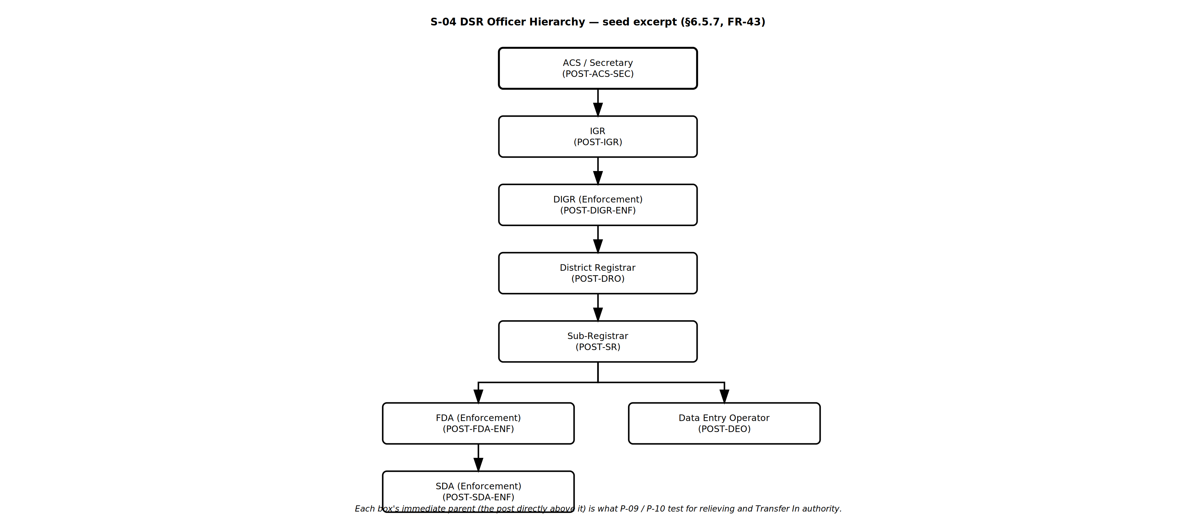
Figure — S-04 Officer Hierarchy Tree — FR-UM-043 — ProcessDiagrams/User_Management/S-04_Officer_Hierarchy_Tree.drawio
Hierarchy Master attributes (Application Admin maintains):

Attribute | Description | Mandatory
Hierarchy Node ID | System-generated unique identifier | Yes (system)
Post | Post from Posts Master (unique Post Code) | Yes
Parent Node | Immediate reporting parent node (null for root); parent must also be a Post | No for root
Division / Branch | Division Code from Division Master (FR-UM-077) | Yes
Display Order | Sort order among siblings under the same parent | Yes
Level | Depth in the tree (0 = root) | Yes (system/derived)
Is Active | Enable / disable node without deleting history | Yes
Effective From / To | Optional validity of the hierarchy link | No
Maintain hierarchy — Application Admin workflow:

Step | Action | Actor | Notes
1 | Open User Management → DSR Officer Hierarchy | Application Admin | FR-UM-043
2 | View tree / list of hierarchy nodes by division | System | Filter by Division, Active status
3 | Add node — select Post from Posts Master, parent Post node, division, display order | Application Admin | Post must exist; FR-UM-043
4 | Edit node — change parent, order, division, or active flag | Application Admin | Cannot create circular parent links
5 | Disable node (soft) if post/structure superseded | Application Admin | History retained; audit logged
6 | Save — hierarchy available for organisational views and admin span rules | System | FR-UM-044 seed structure; each Post has one parent

6.5.8 Office Hierarchy Master
The system shall maintain the hierarchy of DSR offices separately from the Officer (Post) Hierarchy. MS Building is the Secretariat office (root). Under it is IGR Office (Head Office). Under the Head Office are District Registrar Offices. Under each District Registrar Office are Sub-Registrar Offices (FR-UM-059). This hierarchy scopes Transfer Out / Relieving and Transfer In so a superior sees only offices under them; within that list, only posts whose immediate parent is the actor's session Post are actionable (FR-UM-057, FR-UM-060). ACS / Secretary is posted at MS Building (POST-ACS-SEC).
Seed Office Hierarchy (illustrative):

Level | Office Type | Office Code (example) | Office Name (example) | Parent Office
0 | Secretariat | OFF-MS-BLDG | MS Building | — (root)
1 | Head Office | OFF-IGR | IGR Office (Head Office) | OFF-MS-BLDG
2 | District Registrar Office | OFF-DRO-MYS | DRO Mysuru | OFF-IGR
2 | District Registrar Office | OFF-DRO-BLR | DRO Bengaluru | OFF-IGR
3 | Sub-Registrar Office | OFF-SRO-YESH | SRO Yeshwanthapura | OFF-DRO-BLR
3 | Sub-Registrar Office | OFF-SRO-JAY | SRO Jayanagar | OFF-DRO-BLR
3 | Sub-Registrar Office | OFF-SRO-MYS-E | SRO Mysuru East | OFF-DRO-MYS
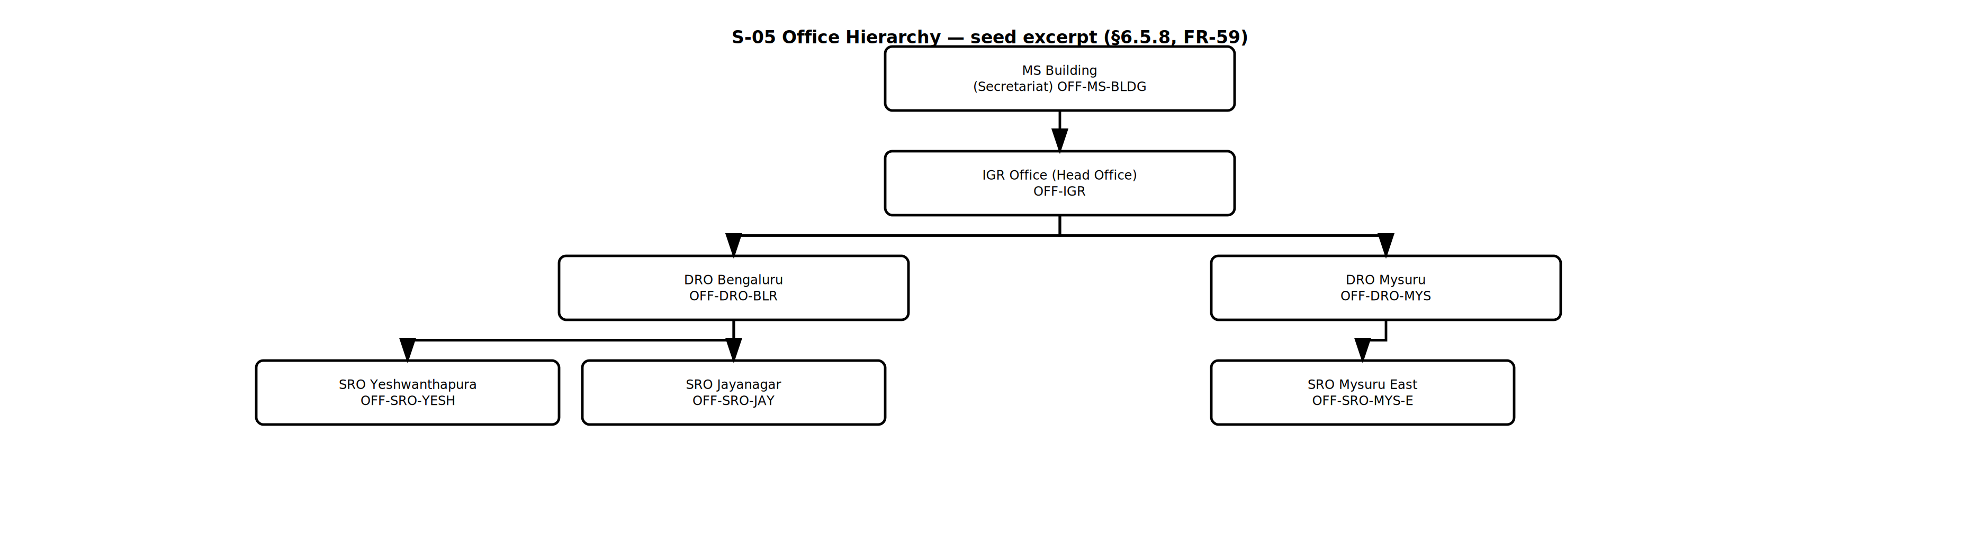
Figure — S-05 Office Hierarchy Tree — FR-UM-059 — ProcessDiagrams/User_Management/S-05_Office_Hierarchy_Tree.drawio
Office span for Transfer Out / Transfer In (examples):

Actor session Office | Offices shown in the tree | May act on (immediate parent only)
MS Building (OFF-MS-BLDG) | IGR Head Office + DRO and SRO offices under the tree | Only posts that report immediately to ACS (e.g. IGR) — not DIGR or Sub-Registrar
IGR Head Office (OFF-IGR) | DRO offices and SRO offices under Head Office (statewide tree) | Only posts that report immediately to IGR (e.g. DIGR) — not Sub-Registrar at an SRO
DRO Bengaluru (OFF-DRO-BLR) | OFF-DRO-BLR + SRO Yeshwanthapura, SRO Jayanagar, … | Sub-Registrar at those SROs (POST-SR reports to POST-DRO) — not FDA/DEO (those report to SR)
SRO Yeshwanthapura (OFF-SRO-YESH) | OFF-SRO-YESH only | FDA / DEO under Sub-Registrar at that SRO only
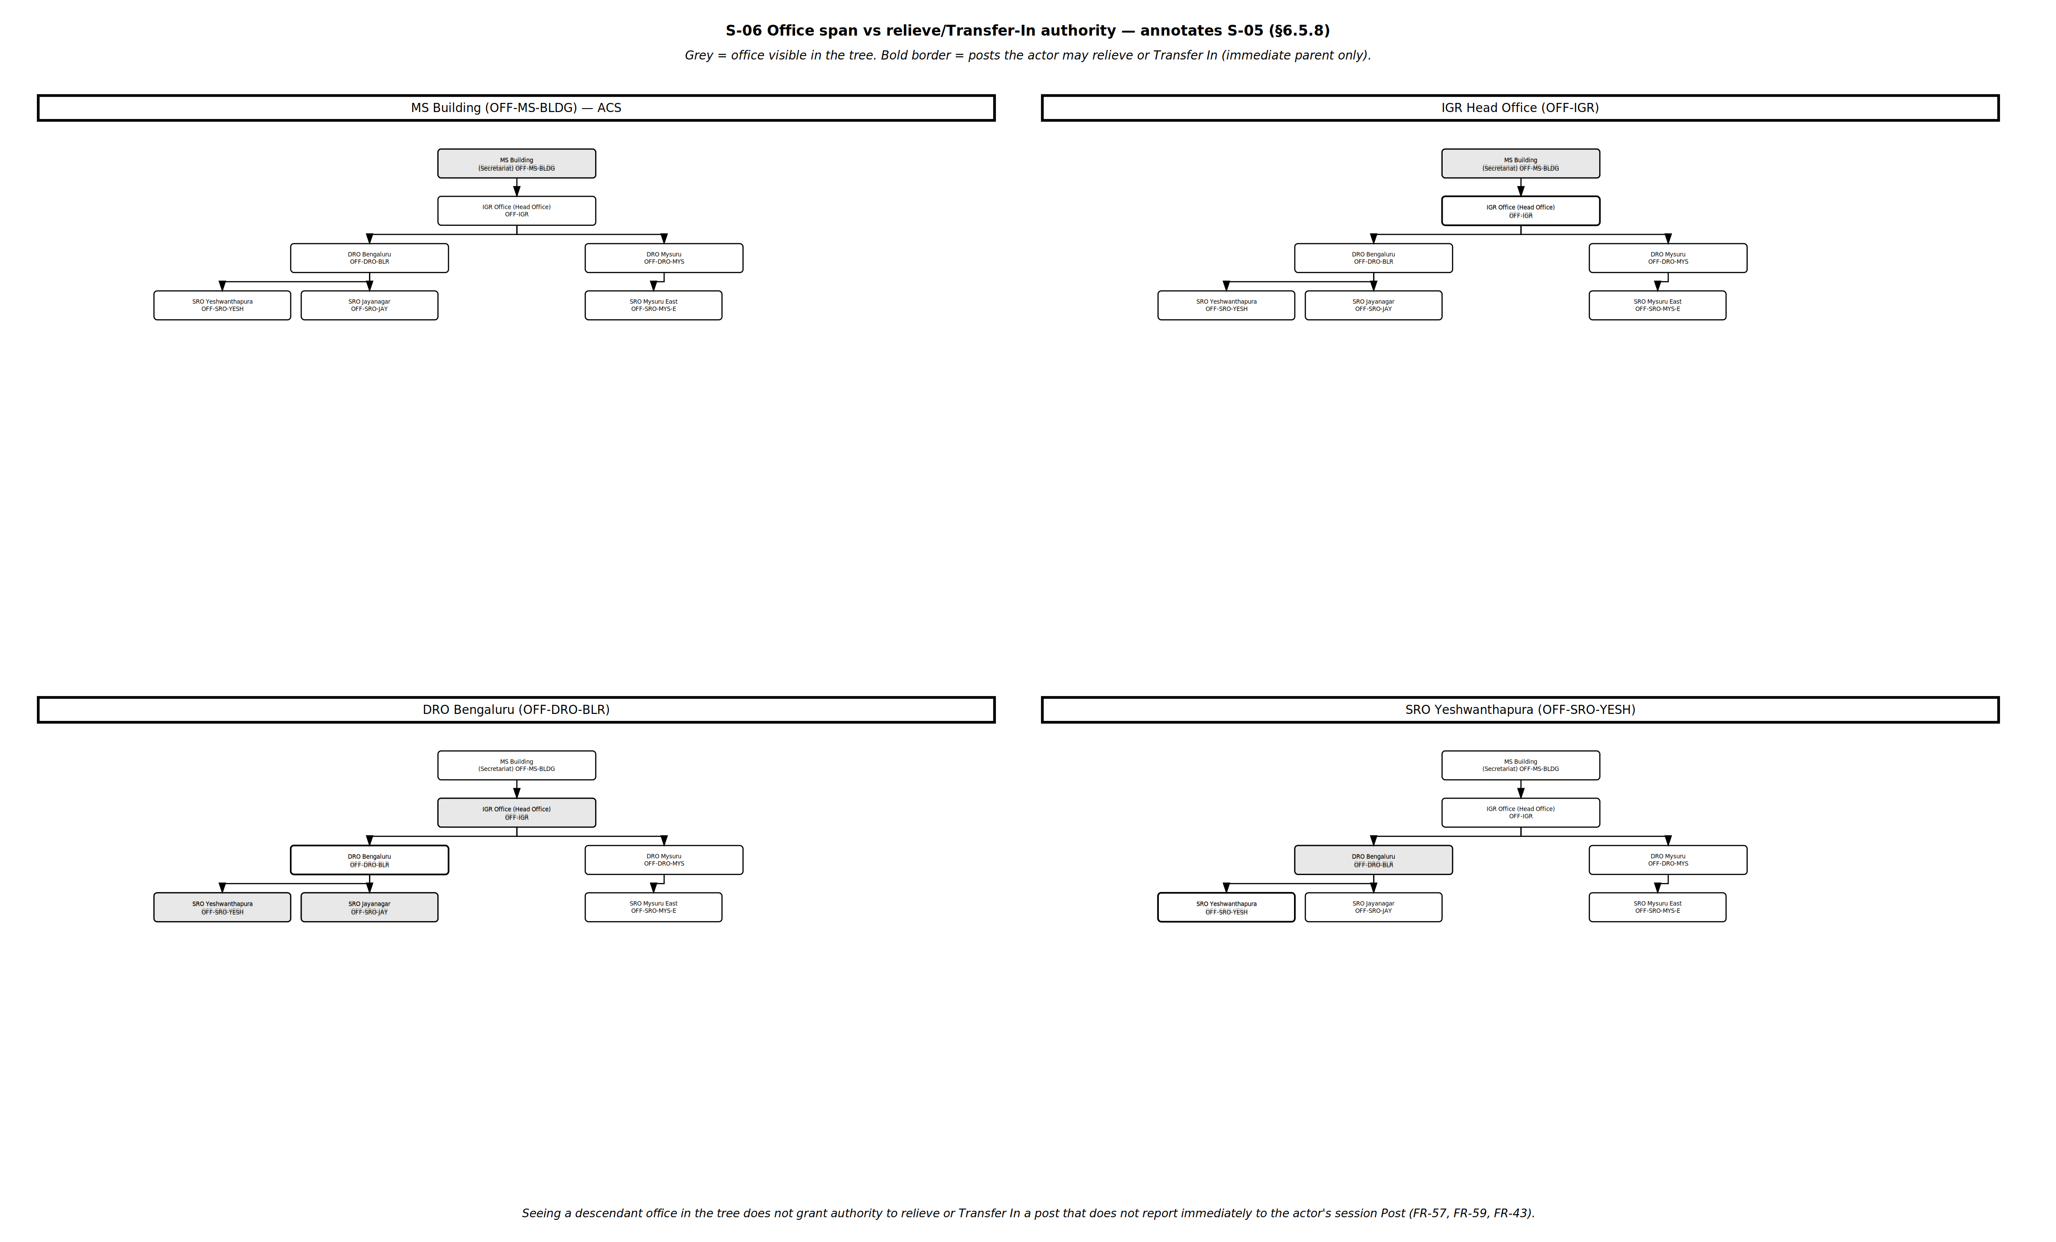
Figure — S-06 Span vs Action — FR-UM-057, FR-UM-059, FR-UM-043 — ProcessDiagrams/User_Management/S-06_Span_vs_Action.drawio

6.6 Administrative User Creation and Role Assignment Workflow
The system shall provide dedicated step-by-step workflows to assign access during user creation. For DSR Officers and Other Department users the KGID is entered first because it becomes the Username (FR-UM-062); the Citizen self-registration flow is set out in 6.1.1. For DSR Officers, assign one or more sanctioned posts with available capacity (roles via Post–Role mapping; no Primary/Secondary; at login the officer selects one post when multiple are active — FR-UM-052). Transfer out / relieving and Transfer In are scoped to offices under the actor, then to posts whose immediate parent is the actor's session Post (6.6.3–6.6.4, FR-UM-057–FR-UM-061, FR-UM-067). Occupancies take effect or end via the occupancy refresh job after midnight IST (FR-UM-068). DSR user creation uses KGID as Username with no security questions; maker-checker is not required (FR-UM-051). For Other Department users, select exactly one role.

6.6.1 DSR Officer User Creation with Post Assignment

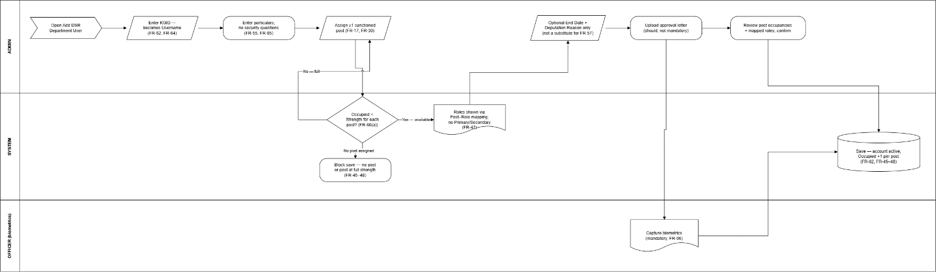

Step | Action | Actor | Notes
1 | Open User Management → Add DSR Department User | Admin | Authorised admin role only (FR-UM-002)
2 | Enter KGID — this becomes the Username | Admin | Validated for presence and uniqueness across User Master (FR-UM-062, FR-UM-064)
2a | Enter remaining particulars (name, official email ID, mobile, photo, ID proof) | Admin | Official email domain validated where configured (FR-UM-064); email and mobile need not be unique (FR-UM-004)
2b | No security questions captured for this category | System | Departmental users have no self-service mobile reset (FR-UM-055, FR-UM-065)
3 | Assign one or more sanctioned posts with available capacity (Post + Office from Posts / Sanctioned Posts Masters) | Admin | At least one required; FR-UM-017, FR-UM-030, FR-UM-045, FR-UM-048, FR-UM-066(a)
4 | Optionally set End Date per post occupancy for time-bound deputations only | Admin | Requires Deputation Reason; ends after 11:59 PM IST on End Date via FR-UM-068 — not a substitute for FR-UM-057 relieving
5 | System shows roles available via Post–Role mapping for each assigned post | System | FR-UM-047; login will use selected post only (FR-UM-052)
6 | Upload approval letter where applicable | Admin | Recommended, not mandatory to save the account
7 | Capture biometrics | Admin / Officer | Mandatory for DSR users (FR-UM-006)
8 | Review post occupancies and mapped roles; confirm | Admin | Multi-post users choose post at each login
9 | Save — account active; occupied count updated per assigned post | System | Blocked if no post assigned or any selected post is at full sanctioned strength (FR-UM-066(a))

6.6.2 Other Department User Creation with Role Assignment
Other Department users are stored in the same User Master (User Category = Other Department). Exactly one role is selected from the Role Master filtered by Role Category = Other Department. There is no Primary/Secondary model for Other Department users. An optional End Date may be entered; if entered, the system shall deactivate the user on that date.

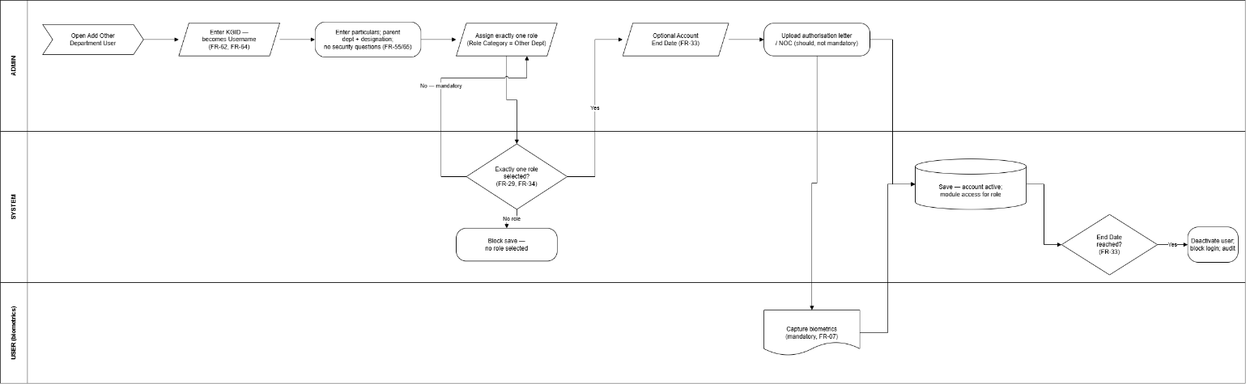

Step | Action | Actor | Notes
1 | Open User Management → Add Other Department User | Admin | Authorised admin role only (FR-UM-003)
2 | Enter KGID — this becomes the Username | Admin | Validated for presence and uniqueness across User Master (FR-UM-062, FR-UM-064)
2a | Enter remaining particulars (name, official email ID of parent department, mobile, photo, ID proof) | Admin | User Category = Other Department; official email validated (FR-UM-064); no uniqueness on email or mobile (FR-UM-004)
2b | No security questions captured for this category | System | No self-service mobile reset (FR-UM-055, FR-UM-065)
3 | Enter parent department and designation | Admin | e.g. Revenue, Treasury, Police
4 | Assign exactly one role from Role Master (Role Category = Other Department) | Admin | Mandatory; FR-UM-029, FR-UM-034
5 | Optionally enter Account End Date | Admin | Not mandatory; FR-UM-033
6 | Upload authorisation letter / NOC from parent department | Admin | Recommended, not mandatory to save the account
7 | Capture biometrics | Admin / User | Mandatory (FR-UM-007)
8 | Review role and End Date (if any) and confirm | Admin
9 | Save — account active with module access for the assigned role | System | Blocked if no role selected
10 | If End Date was entered and is reached — deactivate user; block login | System | FR-UM-033; audit logged

6.6.3 Transfer Out / Relieving Process (DSR Officers)
A DSR Officer may be relieved from currently assigned post occupancy(ies). When Transfer Out / Relieving is opened, the system shall list offices under the actor's session Office per the Office Hierarchy Master — IGR Head Office → District Registrar Offices → Sub-Registrar Offices (FR-UM-059). Within that office span, the system shall list and allow relieving only where the actor's session Post is the immediate parent of the target Post in the Officer Hierarchy (6.5.7, FR-UM-057). Seeing a descendant office (for example an SRO under Head Office) does not allow relieving a Sub-Registrar there. Capture Relieving Date and Relieving Order. Mapping is removed after 11:59 PM IST of the Relieving Date by the occupancy refresh job (FR-UM-058, FR-UM-068).
Examples (Office Hierarchy + Officer Hierarchy):

Actor (session) | Offices shown | May relieve (posts under actor) | Example
District Registrar @ DRO Bengaluru | DRO Bengaluru + its SRO offices only | Sub-Registrar at those SROs (POST-SR reports to POST-DRO) | DRO Bengaluru relieves Sub-Registrar of SRO Yeshwanthapura — not SRO Mysuru East
Sub-Registrar @ SRO Yeshwanthapura | SRO Yeshwanthapura only | FDA / DEO under Sub-Registrar at that SRO | SR Yeshwanthapura relieves FDA at Yeshwanthapura — not another SRO
IGR / DIGR @ IGR Head Office | DRO and SRO offices under Head Office (tree only) | Only posts whose immediate parent is the actor's session Post (e.g. IGR relieves DIGR; DIGR (Enforcement) relieves DRO / HQA (Enforcement)) | Seeing SRO Yeshwanthapura in the tree does not allow IGR or DIGR to relieve the Sub-Registrar there
FDA (Enforcement) @ SRO Yeshwanthapura | SRO Yeshwanthapura only | SDA under FDA at that SRO | FDA relieves SDA at same office

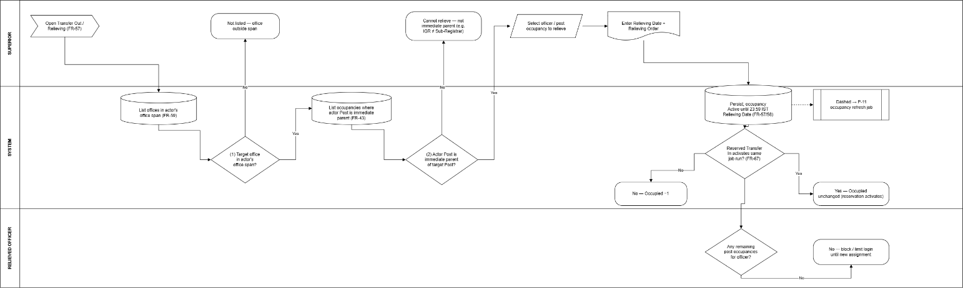

Relieving workflow:

Step | Action | Actor | Notes
1 | Open Transfer Out / Relieving | Superior | FR-UM-057
2 | System lists only offices in actor's office span (Office Hierarchy) | System | FR-UM-059; own office + descendants
3 | Within those offices, list post occupancies where actor Post is immediate parent | System | Officer Hierarchy FR-UM-043
4 | Select officer / post occupancy to relieve | Superior | Cannot see outside span; cannot select posts that do not report immediately to actor
5 | Enter Relieving Date and Relieving Order (upload if applicable) | Superior | Mandatory (FR-UM-057)
6 | Confirm relieving | Superior | Audit-logged; occupancy stays active until end of Relieving Date
7 | Until end of Relieving Date — occupancy remains active | System | Officer may still use post until day closes
8 | Shortly after midnight following Relieving Date — occupancy refresh job de-allocates mapping | System | FR-UM-058, FR-UM-068; occupied count −1 unless a reserved Transfer In activates the same run (FR-UM-067)
9 | If no remaining post occupancies — block / limit login until new assignment | System | Per policy; audit

6.6.4 Transfer In Process (DSR Officers)
Transfer In assigns a DSR Officer to a post within the superior's office span and only where the actor's session Post is the immediate parent of the target Post (same rules as Transfer Out — FR-UM-057, FR-UM-059, FR-UM-043). The system shall capture Transfer Order / Reporting Order and Joining Date (FR-UM-060). Posts with available capacity (Occupied < Sanctioned Strength — FR-UM-066(a)) are selectable without a prior relieving. A post at full strength may receive a future-dated Transfer In only when relieving is already recorded for that Post + Office; recording it reserves capacity immediately (FR-UM-067). A post need not be wholly unoccupied to receive a Transfer In. The officer may log in for that post only from 12:00 AM IST on the Joining Date (FR-UM-061); the occupancy refresh job activates reserved occupancies (FR-UM-068).
Example (handover with reservation): District Registrar at DRO Bengaluru relieves the Sub-Registrar of SRO Yeshwanthapura with Relieving Date 31-Aug-2026. The same DRO then records Transfer In of the incoming officer to that Sub-Registrar post with Joining Date 01-Sep-2026 — even though the outgoing occupancy has not yet ended. Capacity is reserved immediately (FR-UM-067). The incoming officer cannot log in under that post before 01-Sep-2026 12:00 AM IST. Shortly after midnight IST on 01-Sep the occupancy refresh job (FR-UM-068) de-allocates the outgoing officer and activates the incoming occupancy; Sanctioned Posts occupied count stays 1. IGR at Head Office cannot perform this Transfer In because Sub-Registrar does not report immediately to IGR.
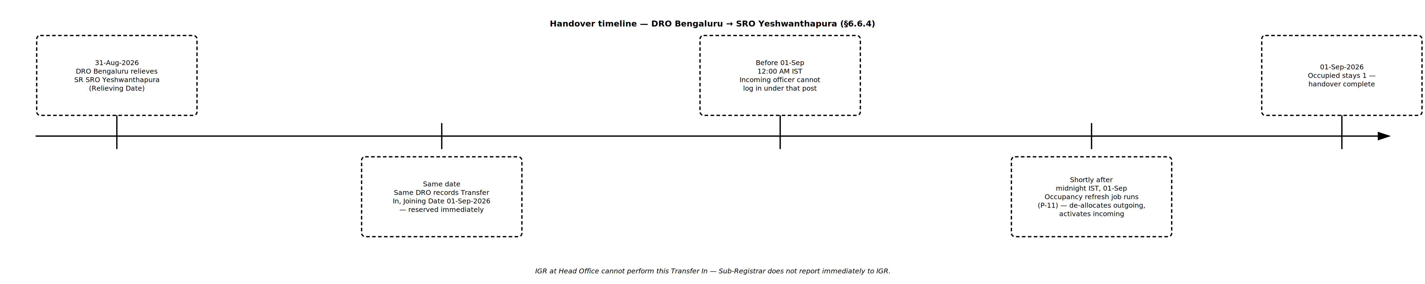
Figure — P-12 Handover Timeline — 6.6.4 — IGR cannot perform this Transfer In — ProcessDiagrams/User_Management/P-12_Handover_Timeline.drawio

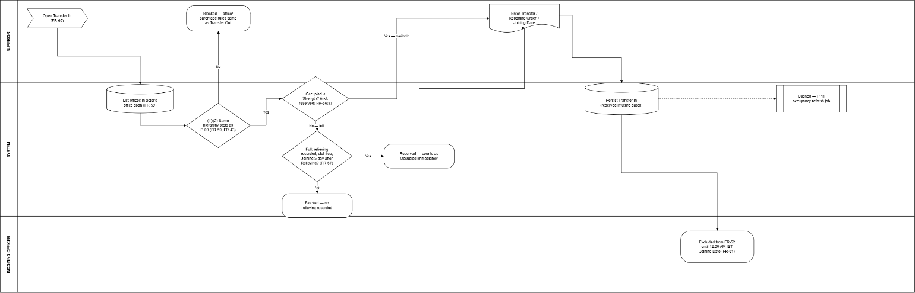

Approved process diagram — P-10 Transfer In — FR-UM-060, FR-UM-061, FR-UM-066(a), FR-UM-067 — ProcessDiagrams/User_Management/P-10_Transfer_In.drawio
Step | Action | Actor | Notes
1 | Open Transfer In | Superior | FR-UM-060
2 | System lists offices in actor's office span | System | FR-UM-059; tree only
3 | Select target Post + Office where actor Post is immediate parent | Superior | Same parentage as FR-UM-057
4 | If post has available capacity — proceed; if at full strength — allow only when relieving already recorded and slot not already reserved | System | FR-UM-066(a), FR-UM-067; else blocked
5 | Select / identify the officer being transferred in | Superior | Existing DSR user (or create then Transfer In per policy)
6 | Enter Transfer Order / Reporting Order (number + upload if applicable) | Superior | Mandatory (FR-UM-060)
7 | Enter Joining Date | Superior | If reserving against relieving: on or after the day after Relieving Date (FR-UM-067)
8 | Confirm Transfer In — occupancy recorded as reserved if Joining Date is in the future; occupied count includes reservation | System | Audit-logged (FR-UM-067)
9 | Before 12:00 AM IST of Joining Date — login with that post blocked | System | FR-UM-061
10 | Shortly after midnight on Joining Date — occupancy refresh job activates occupancy and recalculates Sanctioned Posts occupied count | System | FR-UM-068, FR-UM-052

6.6.5 Occupancy refresh job (after midnight)
Post assignments on the user record and occupied counts on the Sanctioned Posts Master shall not be left to wait for a user to log in. A scheduled job shall run shortly after midnight each day (FR-UM-068) so that Transfer Out, Transfer In, and occupancy End Date take effect on the correct calendar day before the first login.

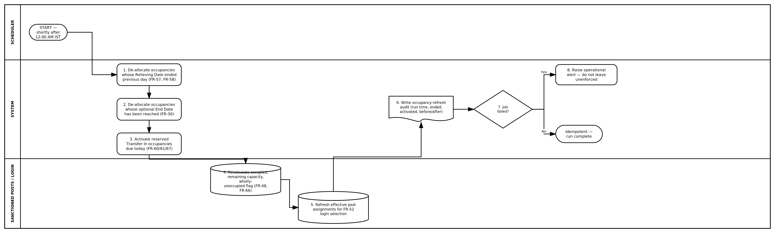
Approved process diagram — P-11 Occupancy Refresh Job — FR-UM-068 — ProcessDiagrams/User_Management/P-11_Occupancy_Refresh_Job.drawio
Step | Action | Actor | Notes
1 | Start occupancy refresh job shortly after 12:00 AM IST | System | FR-UM-068; idempotent
2 | De-allocate occupancies whose Relieving Date ended the previous calendar day | System | FR-UM-057, FR-UM-058
3 | De-allocate occupancies whose optional End Date has been reached | System | FR-UM-030
4 | Activate reserved Transfer In occupancies whose Joining Date is today | System | FR-UM-060, FR-UM-061, FR-UM-067
5 | Recalculate occupied count, remaining capacity, and wholly-unoccupied flag on Sanctioned Posts Master for affected Post + Office rows | System | FR-UM-048, FR-UM-066
6 | Refresh each affected officer's effective post assignments for login selection | System | FR-UM-052; relieved posts no longer selectable; joining posts now selectable
7 | Write occupancy-refresh audit (run time, ended, activated, before/after occupied counts) | System | Mandatory
8 | If the job fails — raise operational alert; do not leave relieving/joining unenforced | System | Risk mitigation

6.6.6 Temporary Absence / Leave / OOD and Temporary Charge (DSR Officers)
This section covers temporary unavailability of a DSR Officer who remains the occupant of their post (Leave, OOD, or Other). It is distinct from Transfer Out / relieving (FR-UM-057), Transfer In (FR-UM-060), deputation End Date (FR-UM-030), and post-login additional charge of a wholly unoccupied subordinate post (FR-UM-053). Full HRMS leave balances and payroll are out of scope — User Management records absence and temporary charge for access control and operational continuity only.
Business rules (summary):
1. Absence is entered by the hierarchy superior only (office span + immediate-parent parentage). The officer cannot self-record Leave / OOD.
2. Absence does not free a slot — Occupied is unchanged; Transfer In must not treat the post as vacant (FR-UM-081).
3. While any effective absence exists on any of the officer's active occupancies, login is blocked entirely (FR-UM-080).
4. The superior may assign Temporary Charge of the absent Post + Office to another subordinate under them, including cross-office peers (FR-UM-082).
5. The covering officer logs in normally and selects the temporary-charge post at FR-UM-052 (FR-UM-083).
User stories / examples:

ID | Actor | Story | Acceptance (system)
US-TA-01 | District Registrar | As District Registrar of DRO Bengaluru, I need to record Leave for the Sub-Registrar of SRO Yeshwanthapura (SRO A) from 01-Sep-2026 to 05-Sep-2026 so that the officer cannot access KAVERI while away, without opening the post for Transfer In. | Absence saved (FR-UM-079); Occupied unchanged (FR-UM-081); SR of SRO A denied login for those dates (FR-UM-080); Transfer In to that SR post still blocked unless relieving/capacity rules allow otherwise.
US-TA-02 | District Registrar | As the same District Registrar, I need to give temporary charge of SRO Yeshwanthapura (SRO A) Sub-Registrar work to the Sub-Registrar of SRO Jayanagar (SRO B) under my district for the leave period. | Temporary charge mapping created (FR-UM-082); SR of SRO B sees a Temporary charge row for SR @ SRO A at FR-UM-052 (FR-UM-083); claims are those of SR @ SRO A while that context is selected; SRO B own post remains available as a separate selectable context.
US-TA-03 | AIGR (Admin) | As AIGR (Admin), I need to record OOD / Leave for District Registrar of DRO Mysuru and assign temporary charge of that DRO post to the District Registrar of DRO Bengaluru (another district under me). | Same FR-UM-079–FR-UM-083 behaviour at DRO post level; cover officer is DRO Bengaluru; absent DRO Mysuru cannot log in; capacity at DRO Mysuru not freed for Transfer In.
US-TA-04 | Covering Sub-Registrar | As Sub-Registrar of SRO B holding temporary charge of SRO A, I need to log in and choose whether to work as SR of B or under temporary charge of A. | FR-UM-052 lists both; one context per session; header shows active context and office (FR-UM-083 / FR-UM-054 pattern).
Examples (who may assign temporary charge):

Superior (session) | Absent occupancy | May assign temporary charge to | Example
District Registrar @ DRO Bengaluru | Sub-Registrar @ SRO A (under DRO) | Any other Sub-Registrar (or eligible subordinate) with an active occupancy under the same DRO — including at SRO B | DRO gives charge of SR @ SRO Yeshwanthapura to SR @ SRO Jayanagar
AIGR (Admin) @ Head Office / Admin span | District Registrar @ DRO Mysuru | Any other District Registrar under the same AIGR | AIGR gives charge of DRO Mysuru to DRO Bengaluru
Sub-Registrar @ SRO Yeshwanthapura | FDA @ same SRO | Another subordinate under that SR at that SRO (office span) | SR records FDA leave and may assign temporary charge to another eligible subordinate under the SR
Approved process diagram — P-13 Temporary Absence / Temporary Charge — FR-UM-079–FR-UM-084 — ProcessDiagrams/User_Management/P-13_Temporary_Absence_Charge.drawio
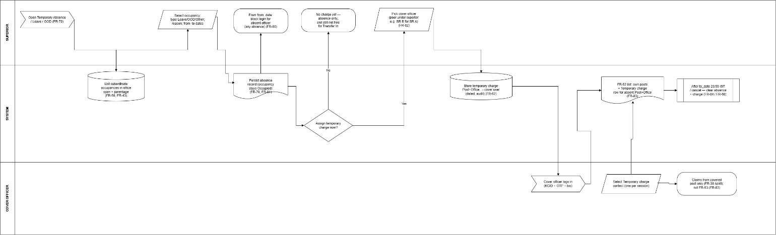

Figure — P-13 Temporary Absence / Leave / OOD and Temporary Charge — 6.6.6 — superior records absence; optional temporary charge to peer under superior (e.g. SR A → SR B); cover officer selects charge at login — ProcessDiagrams/User_Management/P-13_Temporary_Absence_Charge.drawio
Temporary Absence / Temporary Charge workflow:

Step | Action | Actor | Notes
1 | Open Temporary Absence / Leave / OOD | Superior | FR-UM-079; not available to the officer for self-service
2 | System lists offices in actor's office span; within them, occupancies where actor Post is immediate parent | System | FR-UM-059, FR-UM-043 — same filters as FR-UM-057
3 | Select occupancy; enter type (Leave / OOD / Other), reason code, from_date, to_date; optional order | Superior | Mandatory fields per FR-UM-079
4 | Confirm absence — linked record on occupancy; Occupied unchanged | System | FR-UM-079, FR-UM-081; audit-logged
5 | From from_date — deny login for absent Username (any effective absence) | System | FR-UM-080; applies even if other posts are assigned
6 | Optional: assign Temporary Charge of absent Post + Office to another subordinate under the superior (may be different office) | Superior | FR-UM-082; one active charge per Post + Office
7 | Cover officer authenticates; FR-UM-052 lists own posts + Temporary charge row | Cover officer / System | FR-UM-083
8 | Cover officer selects Temporary charge context — claims from covered post only | Cover officer / System | FR-UM-083; distinct from FR-UM-053
9 | After to_date 23:59 IST (or superior cancel) — clear effective absence and temporary charge; absentee may log in again | System | FR-UM-084; FR-UM-068 day-boundary / refresh
Leave / OOD treated as vacancy or FR-UM-053 | High | FR-UM-081 keeps Occupied; FR-UM-082/83 temporary charge is superior-assigned and distinct from FR-UM-053; Transfer In must not open on absence alone | FR-UM-084; FR-UM-068 day-boundary / refresh
Absent officer still logs in on another post | High | FR-UM-080 blocks entire Username login while any effective absence exists | FR-UM-084; FR-UM-068 day-boundary / refresh
FR-UM-053 remains unchanged: session additional charge applies only to wholly unoccupied subordinate posts at the same office. Temporary charge under this section is the path used when the post is still occupied by an officer on Leave / OOD / Other.

6.7 Administrative User Management
Req ID | Requirement | Priority
FR-UM-020 | The system shall allow administrators to create, edit, suspend, and deactivate user accounts by category. Deactivation shall require a reason and shall be audit-logged (supersedes retired FR-UM-015). | High
FR-UM-021 | The system shall allow administrators to search and filter users by Username (including KGID for departmental users), category, role, office, division, and status. | Medium
FR-UM-022 | The system shall log all administrative actions performed on user accounts. | High
FR-UM-023 | The system shall notify a user via SMS/email when their account is created, suspended, or deactivated. | Medium
Temporary Absence | Superior-recorded Leave / OOD / Other period linked to an active post occupancy with reason and from–to dates (FR-UM-079); does not end the occupancy or free Transfer In capacity | Medium
Effective absence | An Approved temporary absence whose from_date–to_date covers the current IST calendar day | Medium
OOD | Out of Duty / Office Duty — an absence type under Temporary Absence (FR-UM-079) | Medium
Temporary Charge | Superior-assigned, dated mapping of an absent Post + Office to another subordinate officer under the same superior (may be cross-office); cover officer selects it at FR-UM-052 (FR-UM-082, FR-UM-083); distinct from FR-UM-053 additional charge | Medium
Cover officer | DSR Officer who holds Temporary Charge of another officer's Post + Office during Temporary Absence | Medium

7. Non-Functional Requirements
Category | Requirement
Security | No password storage — authentication is OTP-based only; the login OTP is sent only to the registered mobile.
Security | OTP and session policy is defined in FR-UM-069–FR-UM-076: login OTP 5 minutes; registration/recovery OTP and reset PIN 10 minutes; 6 digits; 3 incorrect entries per code; 30-second resend cooldown (max 3 per 15 minutes); 5 failed login attempts lock Username 15 minutes; idle timeout 15 minutes; absolute session 8 hours; one active session per Username.
Security | All data in transit shall be encrypted using TLS 1.2 or higher.
Security | Biometric data for departmental users shall comply with Aadhaar Act, 2016 and UIDAI guidelines.
Security | Security-question answers shall be stored hashed/encrypted, shall never be displayed or retrievable in clear text, and shall never be entered or viewed by an administrator.
Security | The Citizen lost-mobile reset shall require two independent proofs — three of five security questions answered correctly and a single-use PIN delivered to the registered email — before a new mobile number may be entered, and the new number shall itself be OTP-verified before the change takes effect.
Security | The reset PIN shall be single-use and time-limited; question and PIN attempts shall be rate-limited and the reset flow locked after a configured number of failures.
Security | No pre-login self-service path shall exist to change the mobile number, email address, or Username of a DSR Officer or Other Department user.
Performance | OTP dispatch (SMS to mobile only) shall complete within 5 seconds of user request.
Performance | Registration verification OTPs (email and mobile) and the reset PIN to email shall be dispatched within 30 seconds of request.
Performance | Login and authentication requests shall complete within 2 seconds after OTP/biometric verification.
Availability | The occupancy refresh job (FR-UM-068) shall complete shortly after midnight so that relieving ended the previous day and Transfer In joining the current day are reflected before the first login of the day; job failure shall raise an operational alert.
Usability | Registration and OTP login workflows shall be completable on desktop and mobile browsers.
Usability | Username availability shall be checked and reported to the citizen during registration before submission, with suggestions where the chosen Username is taken.
Auditability | All create, update, delete, login, mobile-update, email-update, Citizen lost-mobile reset, administrator-initiated mobile change, access-control, Transfer Out / Transfer In, and occupancy-refresh job actions shall be logged with timestamp and actor.
Compliance | Citizen-facing UI shall support Kannada and English (bilingual) per Karnataka e-Governance norms.
Compliance | Citizen-facing UI shall comply with Government of India Guidelines for Indian Government Websites (GIGW) accessibility requirements.
Compliance | Personal and authentication data shall reside in India; production hosting shall use MeitY-empanelled cloud / data-centre infrastructure as applicable to KAVERI 3.0.
Compliance | The module shall comply with Karnataka e-Governance, MeitY/CERT-In, the DPDP Act 2023, and applicable Karnataka state data-protection norms.
Performance | The system shall support a minimum of 500 concurrent authenticated user sessions at launch; peak-load targets shall be validated during performance testing with Kaveri IT Cell.
Availability | Disaster recovery shall target RPO ≤ 24 hours and RTO ≤ 4 hours for the User Management module and its database, subject to platform-wide DR architecture.
Usability | Supported browsers: latest two stable versions of Google Chrome and Microsoft Edge on Windows; citizen flows shall also work on current Android and iOS mobile browsers.
Auditability | Audit logs for security, authentication, access control, Transfer Out / Transfer In, and administrative actions shall be retained for at least seven (7) years unless a longer DSR records-retention rule applies.
Compliance | PII retention and purge policy: user PII shall be retained while the account is active and for the audit-retention period thereafter; purge/anonymisation of dormant Citizen accounts shall follow a policy defined by the Department before go-live.

8. Reporting Requirements
- The system shall provide a report of all active, inactive, and suspended users.
- The system shall provide an audit log report of login attempts (successful and failed) over a selected date range.
- The system shall provide a report of role and permission assignments across all users.
The system shall provide a sanctioned post occupancy report showing, for each office, the number of sanctioned posts per Post (from Posts Master), occupied count, remaining capacity, and whether the post is wholly unoccupied (FR-UM-066).
The system shall provide a Role-to-Module mapping report showing which modules and functions are assigned to each role.
The system shall provide a single contact-change and recovery report over a selected date range covering: (a) Citizen lost-mobile / security-question recovery attempts (FR-UM-056) — Username, questions presented, PIN dispatch outcome, new mobile OTP outcome, success/failure, actor, and timestamp; (b) administrator-initiated mobile changes for departmental users (FR-UM-065); and (c) email changes (Citizen self-service or admin) — showing actor, user, channel changed, timestamp, outcome, and failed attempt counts. One report; do not build separate overlapping recovery reports.
The system shall provide an additional charge report (FR-UM-053) showing, for each officer and date range, when additional charge was taken or cleared, the assigned post, the subordinate post, office, and audit timestamp.
The system shall provide a Temporary Absence and Temporary Charge report (FR-UM-079–FR-UM-084) over a selected date range showing each absence (officer, Post + Office, type, reason, from/to dates, actor) and each temporary charge assignment or clearance (cover officer, covered Post + Office, timestamps).
The system shall provide an occupancy-refresh report (FR-UM-068) showing, for each midnight job run, occupancies de-allocated (relieving / End Date), reserved Transfer In occupancies activated, and Sanctioned Posts occupied-count changes (Post + Office, before/after counts).
The system shall provide a Transfer Out / Transfer In history report (FR-UM-057–FR-UM-061, FR-UM-067) over a selected date range showing each relieving and Transfer In event — actor, officer, Post + Office, order reference, Relieving Date or Joining Date, reserved vs active status, and audit timestamp.
The system shall provide an officer posting and service history report showing, for each DSR Officer, the chronological list of post occupancies (Post + Office), assignment / Transfer In / relieving / End Date events, and effective date ranges.

9. Acceptance Criteria
The User Management Module will be considered accepted when:
- All functional requirements listed in Section 6 have been implemented and pass QA testing, including the UAT scenarios below.
UAT — FR-UM-052: A DSR Officer with two active post occupancies must select one post labelled Role — Post Name — Office Name (Office Code) before home; a single occupancy auto-selects; claims derive only from the selected assigned post.
UAT — FR-UM-053: After login at SRO Yeshwanthapura, additional charge lists only wholly unoccupied subordinate posts at that same office; empty posts at another SRO (e.g. Jayanagar) are not offered; privileges switch to the additional-charge post only until switch-back (FR-UM-038).
UAT — FR-UM-058 / FR-UM-068: Relieving with Relieving Date D keeps occupancy through 11:59 PM IST of D; the occupancy refresh job shortly after midnight IST de-allocates it and updates occupied counts.
UAT — FR-UM-061 / FR-UM-067: Future-dated Transfer In against a full post is allowed only after relieving is recorded; reserved occupancy counts toward Occupied immediately; login for that post is blocked until 12:00 AM IST of Joining Date; the midnight job activates it that day.
UAT — FR-UM-069–FR-UM-076: Login OTP expires after 5 minutes; 6 digits; 3 incorrect entries invalidate the code; 30-second resend cooldown; 5 failed logins lock Username 15 minutes; idle timeout 15 minutes; session ends at 8 hours; a second login ends the prior session.
UAT — FR-UM-079–FR-UM-084: District Registrar records Leave for Sub-Registrar of SRO A; that SR cannot log in; Occupied unchanged; DRO assigns temporary charge to Sub-Registrar of SRO B; SRO B SR sees Temporary charge for SRO A at FR-UM-052 and receives SR@A claims when selected; after to_date the charge disappears and SRO A SR may log in again. FR-UM-053 still requires Occupied = 0 and is not used for this path.
- UAT — Role–Module–Function coverage: before go-live, Role–Module–Function mapping has been completed (not left as illustrative example rows) and confirmed by the Domain Expert for every active Role Master entry and every active Module in the Module Master, so that no DSR, Citizen, or Other Department role is left with unintended zero access.
- All non-functional requirements listed in Section 7 have been verified and validated.
- User acceptance testing (UAT) has been completed and signed off by Prashanth (Product Owner), including the scenarios listed in Section 9.
- Security review/penetration testing has been completed with no critical or high-severity findings open.
- Relevant documentation (user guide, admin guide) has been delivered.

10. Risks and Mitigations
Risk | Impact | Mitigation
OTP delivery failure (SMS) | High | Retry mechanism; allow mobile update after login (FR-UM-013); Citizen lost-mobile reset (FR-UM-056); administrator-initiated change for departmental users (FR-UM-065).
Biometric device unavailability | Medium | Biometrics are mandatory on every login for DSR and Other Department users (FR-UM-006, FR-UM-007) with no exception path — offices must maintain working devices; no biometric fallback is in scope.
Account takeover via lost-mobile reset | High | Two independent proofs required — three of five questions plus single-use PIN to registered email — and OTP verification of the new mobile; attempts rate-limited and flow locked after configured failures; change notified to registered email and audit-logged (FR-UM-056).
Security-question answers known to a third party | Medium | Answers are self-entered by the citizen only, stored hashed, never displayed, and never captured by an administrator; departmental users hold no security questions at all (FR-UM-055, FR-UM-065).
Citizen has lost both mobile and access to registered email | Medium | Assisted recovery at a designated counter with documentary identity verification and supervisory approval, fully audit-logged; no purely remote path.
Security-question answers forgotten | Medium | Assisted recovery with strong documentary identity verification and audit; no override of the two-proof rule.
Username squatting or impersonating Usernames | Medium | Reject reserved and misleading Username patterns (e.g. names resembling official designations); Username uniqueness enforced across the whole User Master (FR-UM-062).
Over-capacity post assignment | High | Enforce sanctioned strength validation; block assignment when the post at that office is at full strength (FR-UM-066(a)).
Vacancy tests confused in build | High | FR-UM-066 defines available capacity and wholly unoccupied separately; FR-UM-053 additional charge uses Occupied = 0; active context is either assigned post or additional charge post, not both (FR-UM-038)
Post occupancy end date / relieving not enforced | High | Occupancy refresh job shortly after midnight (FR-UM-068) de-allocates relieving (FR-UM-058) and occupancy End Date (FR-UM-030); reserved Transfer In activated on Joining Date; audit alert on job failure.
Unmapped post assigned or sanctioned | High | FR-UM-047 blocks sanction/assignment without Post–Role mapping; seed mapping covers all active Posts; Domain Expert to confirm before go-live.
OTP/session policy | High | Enforce FR-UM-069–FR-UM-076 as specified (including 15-minute idle timeout on shared SRO counters with FR-UM-052/FR-UM-053).
Unauthorised relieving / transfer in | High | Scope to offices under actor (FR-UM-059) then immediate-parent posts only (FR-UM-043, FR-UM-057); seeing a descendant office does not grant SR transfer to IGR/DIGR; available capacity or FR-UM-067 reservation required for Transfer In (FR-UM-060, FR-UM-066(a)).
Joining Date login gate not enforced | High | Block login for Transfer In occupancy until 12:00 AM IST of Joining Date (FR-UM-061); FR-UM-068 activates reserved occupancy that day.
Double-booking a full post during handover | High | FR-UM-067 reserves capacity when relieving is recorded; reserved occupancy counts toward Occupied so a second Transfer In cannot take the same slot.
Other Department end date not enforced | Medium | Scheduled job to deactivate Other Department users on optional End Date; audit alert.
Scope creep beyond OTP-only auth | Medium | Maintain strict change-control; no password management in KAVERI 3.0.
Delayed stakeholder sign-off | Low | Set clear review deadlines and escalation path.
Role–Module–Function mapping incomplete at go-live | High | Only Sub-Registrar (SR), FDA (Enforcement), DEO, Citizen roles, and one Other Department role have seeded Module Function mappings; the remaining ~37 DSR roles and 3 of 8 Module Master entries (Stamp Duty / Payments, Firm / Society Registration, MIS / Dashboards) currently have none. Unlike Post–Role mapping (FR-UM-047), which is seeded complete for all active Posts, this matrix carries no completeness commitment. Require Application Admin, with Domain Expert sign-off, to complete Role–Module–Function mapping for all active roles and modules before go-live (see UAT scenario in 9).
Shared email weakens Citizen lost-mobile reset for linked accounts | Medium | Email and mobile carry no uniqueness constraint across the User Master (FR-UM-004), so a shared email address (e.g. family members) already satisfies one of FR-UM-056's two required proofs for every account tied to it, and security-question answers may be more easily known within a shared household. Consider a lower per-email daily attempt threshold on the reset flow and a notice to the shared email itself naming which account triggered the reset, in addition to existing rate-limiting and audit logging.
Repeated OTP + biometric re-authentication may slow high-volume SRO counters | Medium | FR-UM-074 (15-minute idle timeout) combined with FR-UM-005–FR-UM-007 (OTP and biometrics on every fresh login) adds authentication overhead at busy Sub-Registrar counters. Beyond functional UAT (9), measure end-to-end re-authentication time during performance testing with Kaveri IT Cell and confirm it is acceptable at peak walk-in volumes.
Role/Post naming ambiguity — Sub-Registrar (SR) vs Sub Registrar (Admin)/(Computers) | Medium | The Enforcement signing-authority role is distinguished from the similarly named Admin/Computers roles only by a hyphen and a different suffix convention; the Glossary already flags related SRO-vs-role-name confusion. FR-UM-050's exact-name validation prevents backend mis-mapping but does not protect UI labels, reports, or verbal handovers from confusion. Domain Expert to confirm the naming convention (e.g. a more distinct name such as “Sub-Registrar (Enforcement)”) before go-live.

11. Glossary
Term | Definition
BRD | Business Requirements Document
RBAC | Role-Based Access Control
OTP | One-Time Password — the login OTP is sent only to the registered mobile (SMS); separate one-time OTPs verify the email address and mobile number at Citizen registration (FR-UM-063) and verify a new mobile number; no static password exists
Username | The unique login identifier for every account, unique across the whole User Master: a preferred Username chosen by the citizen for Public users, and the KGID for DSR Officers and Other Department users (FR-UM-004, FR-UM-062)
Preferred Username | The Username a citizen chooses for themselves during self-registration, subject to an availability check against the entire User Master (FR-UM-062)
KGID | Karnataka Government Insurance Department number — used as the Username (unique login identifier) for DSR Officers and Other Department users (FR-UM-062, FR-UM-064); not a separate field from Username
Division Master | Enumerated master of DSR organisational divisions (Division Code, Division Name); referenced by Posts Master and Hierarchy Master (FR-UM-077)
Post–Office-Type Allowed mapping | Rules defining which Post codes may be sanctioned at which Office Types; invalid combinations blocked (FR-UM-078)
Official email ID | Government or parent-department email address recorded for DSR Officers and Other Department users in place of a personal address; validated against the permitted domain list where configured (FR-UM-064)
Security question | One of five questions selected by a citizen at registration with a secret answer; three are asked at random during lost-mobile reset; not held for departmental users (FR-UM-055, FR-UM-056)
Reset PIN | Single-use, time-limited code sent to a citizen's registered email address as the second independent proof in the lost-mobile reset flow (FR-UM-056)
Lost-mobile reset | Citizen-only pre-login flow to replace the registered mobile number: three of five security questions, then a PIN to the registered email, then OTP verification of the new number (FR-UM-056); not available to departmental users (FR-UM-065)
DSR | Department of Stamps and Registration, Government of Karnataka
UAT | User Acceptance Testing
IGR | Inspector General of Registration
DIGR | Deputy Inspector General of Registration
AIGR | Assistant Inspector General of Registration
Sanctioned post | A Posts Master entry sanctioned at a specific office with approved strength; Post + Office + Strength
Sanctioned strength | The approved number of occupants for a given Post at a given office
Available capacity | Vacancy test used for post assignment and Transfer In: occupied count (active occupancies plus reserved Transfer In occupancies) for a Post at an Office is less than its sanctioned strength (FR-UM-066(a), FR-UM-067)
Wholly unoccupied post | Vacancy test used only for FR-UM-053 post-login additional charge: the occupied count for a Post at an Office is zero, irrespective of sanctioned strength (FR-UM-066(b)); reserved Transfer In also counts as occupied
Posts Master | Separate catalogue of DSR establishment posts (distinct from Role Master)
Post–Role mapping | Table linking a Post to one or more Roles; one post may map to multiple roles
Office | A concrete DSR office instance (e.g. IGR Head Office, DRO Mysuru, SRO Yeshwanthapura)
Office Hierarchy Master | Tree of DSR offices: MS Building (Secretariat, root) → IGR Head Office → District Registrar Offices → Sub-Registrar Offices (FR-UM-059)
MS Building | Secretariat office (Office Code OFF-MS-BLDG); Office Hierarchy root; office of POST-ACS-SEC (ACS / Secretary)
Secretariat (Office Type) | Office Type for MS Building, distinct from Head Office (IGR Office) (FR-UM-059, FR-UM-078)
Office span | The actor's session Office plus all descendant offices in the Office Hierarchy Master; first filter for Transfer Out / Transfer In lists — actions remain limited to posts whose immediate parent is the actor's session Post (FR-UM-057, FR-UM-060)
Role Master | Single master of all roles for Citizens, DSR Officers, and Other Department users; differentiated by Role Category
User Master | Single master of all users across categories; differentiated by User Category
Role Category | Attribute on a role in the Role Master: Citizen, DSR, or Other Department
User Category | Attribute on a user in the User Master: Public (Citizen), DSR Officer, or Other Department
Module Master | Catalogue of application modules (e.g. Registration of Documents, Marriage Registration, Encumbrance Search, Certified Copy)
Module Function Master | Catalogue of privilege verbs under a module — e.g. VIEW, ADD, EDIT, APPROVE, SIGN, PRINT, DOWNLOAD
Resource Master | Catalogue of APIs and URLs linked to a Module Function (type, HTTP method, path pattern)
Role–Module–Function mapping | Association of a Role Master role (exact unique name) to one or more Module Functions; Application Admin system privileges are not represented here (FR-UM-051)
Module function | Privilege verb within a module — e.g. VIEW, ADD, EDIT, APPROVE, SIGN, PRINT, DOWNLOAD
Resource | An API endpoint or UI URL/route protected by a Module Function
Access enforcement | Runtime check: request path/method → Resource → required Module Function → user's role claims
Application Admin | System-level / deployment-seeded actor who maintains masters; not a Role Master seed role; privileges outside Role–Module–Function mapping (FR-UM-051)
DSR Officer Hierarchy Master | Master of reporting relationships among DSR Posts (Posts Master) as per the Department organisational chart
Hierarchy node | A node in the DSR Officer Hierarchy Master linking a Post to an optional parent Post node
Unique role name | Distinct Role Master name including division context where needed (e.g. FDA (Admin), FDA (Enforcement)) — no duplicate bare FDA/SDA/Typist entries
Other Department role | A role in the Role Master with Role Category = Other Department; exactly one such role is assigned per Other Department user
Post occupancy | Assignment of a DSR user to a sanctioned post at an office; roles follow from Post–Role mapping for the assigned post at login (FR-UM-052); no Primary/Secondary distinction
Relieving / Transfer out | Process by which a superior removes a DSR Officer from a post occupancy within the superior's office span and immediate-parent posts only, capturing Relieving Date and Relieving Order (FR-UM-057–FR-UM-059); mapping ends after 11:59 PM IST of that date via the occupancy refresh job (FR-UM-058, FR-UM-068)
Relieving Date | Calendar date captured during relieving; user–post mapping is removed after 11:59 PM IST of this date by the occupancy refresh job (FR-UM-068)
Relieving Order | Order number / reference (and optional uploaded order document) recorded when relieving an officer
Transfer In | Process by which a superior assigns a DSR Officer to a post within office span and immediate-parent posts only, capturing Transfer/Reporting Order and Joining Date (FR-UM-060, FR-UM-066(a)); when the post is full, allowed only if relieving is already recorded and capacity is reserved (FR-UM-067); login from 12:00 AM IST on Joining Date (FR-UM-061)
Reserved occupancy | A future-dated Transfer In recorded against a Post + Office after relieving is captured; counts toward Occupied immediately so the slot cannot be double-booked; incoming officer cannot log in until Joining Date (FR-UM-067, FR-UM-061)
Joining Date | Calendar date captured during Transfer In; login for that post occupancy is allowed only from 12:00 AM IST of this date onwards; the occupancy refresh job activates reserved occupancies on this date (FR-UM-061, FR-UM-068)
Sub-Registrar Office (SRO) | Office Type in Office Hierarchy Master — not a role name; do not use SRO as a Role Master name (use Sub Registrar (Admin) or Sub Registrar (Computers) instead)
Deputation Reason | Mandatory code when optional occupancy End Date is set under FR-UM-030; End Date is for time-bound deputations only, not a substitute for relieving
Is Public | Resource Master flag: Yes allows unauthenticated access; default No — deny-by-default at runtime (FR-UM-040, FR-UM-041)
Occupancy refresh job | Scheduled job shortly after midnight IST that de-allocates relieved and ended occupancies, activates reserved Transfer In occupancies whose Joining Date is today, recalculates Sanctioned Posts occupied counts, and refreshes officers' effective post assignments for login (FR-UM-068)
Transfer / Reporting Order | Order number / reference (and optional uploaded document) recorded when transferring an officer into a post
Login post selection | After authentication, when a DSR Officer has multiple active post occupancies, the mandatory step to choose one Post (shown with Office details) for the session (FR-UM-052)
Assigned post | The sanctioned post (Post + Office) selected or auto-selected at login under FR-UM-052; fixed for the session unless the officer logs out and logs in again with a different choice
Additional charge | Temporary in-office cover of a wholly unoccupied subordinate post under the assigned post, taken after login under FR-UM-053 without logout or order; session privileges derive from the additional charge post only while active; switch back to assigned post to restore assigned-post privileges (FR-UM-038)
Session post | Synonym for assigned post (FR-UM-052) in audit and reporting contexts; distinct from additional charge post under FR-UM-053
Additional charge switch | Post-login action allowing a DSR Officer to take or clear additional charge of a wholly unoccupied subordinate post at the same office (FR-UM-053, FR-UM-066(b)); no logout required
Session Post–Role display | After login, persistent display of assigned Post with Role(s); when FR-UM-053 is active, shows which context drives session privileges — assigned post or additional charge post (FR-UM-054)
Parent department | The government department to which an Other Department user belongs (e.g. Revenue, Treasury, Police)
Account End Date | Optional date on an Other Department user account; if set, the system deactivates the user on that date

12. Approval
By signing below, the stakeholders confirm they have reviewed and approved this Business Requirements Document.
Name | Role | Signature | Date
Prashanth | Product Owner
Prabhakar Naik | Domain Expert
Kaveri IT Cell Lead | IT Security / Engineering

